

CUSTOMER RETENTION PROJECT

Submitted by: Umesh

ACKNOWLEDGMENT

I would like to express my special thanks of gratitude to all the Mentors who have taught me Machine Learning because of the knowledge they had provided to me I am able to complete this project.

TABLE OF CONTENT

1. What is Customer Retention?
2. Why is customer retention important?
3. Customer retention benefits.
4. Review of Literature

INTRODUCTION

Customer Retention refers to the action and strategies a business uses to try and keep existing customers. To enable these actions, customer retention analytics provide predictive metrics of which customer might churn-which enable them to get ahead of it. Customer satisfaction has emerged as one of the most important factors that guarantee the success of online store; it has been posited as a key stimulant of purchase, repurchase intentions and customer loyalty. A comprehensive review of the literature, theories and models have been carried out to propose the models for customer activation and customer retention. Five major factors that contributed to the success of an e-commerce store have been identified as: service quality, system quality, information quality, trust and net benefit. The research furthermore investigated the factors that influence the online customers repeat purchase intention. The combination of both utilitarian value and hedonistic values are needed to affect the repeat purchase intention (loyalty) positively. The data is collected from the Indian online shoppers. Results indicate the e-retail success factors, which are very much critical for customer satisfaction.

1. **What is Customer Retention?**

Customer Retention refers to a company’s ability to turn customers into repeat buyers and prevent them from switching to a competitor. It indicates whether your product and the quality of the service please your existing customers.

Customer Retention strategies are the processes and initiatives businesses put in place to build customer loyalty and improve customer lifetime value.

1. **Why is customer retention important?**

Customer retention increases your customers’ lifetime value and boosts your revenue. It also helps you build amazing relationship with your customers. You aren’t just another website or store. They trust you with their money because you give them value in exchange. According to the Harvard Business Review, acquiring a new customer can be 5 to 25 times more expensive than holding on to an existing one. You don’t need to spend big on marketing, advertising or sales outreach. It is easier to turn existing customers into repeating ones, since they already trust your brand from previous purchases. New customers, however, often require more convincing when it comes to the initial sale.

1. **Customer Retention benefits:**
   * Retention is Cheaper than Acquisition
   * Loyal Customers are more profitable.
   * Your Brand will stand out from the crowd.
   * Engage customers provide more feedback.
   * Loyal customers are more forgiving.
   * Customers will explore your brand

**REVIEW OF LITERATURE**

Customer satisfaction has emerged as one of the most important factors that guarantee the success of online store; it has been posited as a key stimulant of purchase, repurchase intentions and customer loyalty. A comprehensive review of the literature, theories and models have been carried out to propose the models for customer activation and customer retention. Five major Factors that contributed to the success of an e- commerce store have been identified as service quality, system quality, information quality, trust and net benefit. The research furthermore investigated the factors that influence the online customers repeat purchase intention.

* Purchase intention :

Purchase intention can be characterized as the probability that an online client will

purchase an item and keep on buying items from a similar online retailer . This essential develop "customers purchase choice” is clarified in the model regard to its relationship with another key factors (user satisfaction, trust and net advantage).

* User satisfaction :

Satisfaction has been characterized as an individual sensation of happiness or delight,

because of contrasting the genuine result of shopping on the web as against their assumption. Satisfaction of on the web customers will emphatically affect their future intention (repeat purchase) straightforwardly or by implication.

* Net advantages :

This is utilized to portray the absolute advantages of got when shopping online by

customers, as against the expenses (for instance, exertion, cash and time). A portion of the net advantages got from web-based shopping include: money related increase, item search and purchasing adequacy, accommodation, ideal conveyance, happiness, wide item reach, and adaptability. Agreeing to an examination by Childers et al. (2001), net advantage of shopping online incorporates both utilitarian worth and gluttonous qualities.

* Data quality

This can be characterized as the customers' insights towards the show also, qualities of

data introduced or showed in an online business site, web application or gateway. It takes the qualities of data into thought, for instance, practicality, pertinence reasonable, exactness, and fulfillment. One of the essential obligations of an e-posterior is to guarantee the accessibility of complete data on items being offered, the value-based cycle included, and administrations to be delivered. Showing excellent data on the site can invigorate a further developed change rate too as better customers' satisfaction.

* Framework quality

This can be portrayed as the users' impression of the online retail site's capacity to

proficiently give mentioned data just as its conveyance strategy. Framework quality examinations the exhibition of the site; a portion of the measurement incorporates; page load speed, simplicity of route between pages, web architecture, appearance, site accessibility, and site format. Innovation acknowledgment model (TAM) states that, an e-retail site which is viewed as being not difficult to utilize is most liable to achieve a

sensation of energy among the shoppers. Szymanski furthermore, Hise (2000) likewise believed that the exhibition of a site plays out a critical job in choosing satisfaction of the customers while shopping on the site. At the point when customers purchase an item from a site or web application, usefulness obstacles (for instance, Site crash, interference) may bring about a helpless client user experience (Collier and Bienstock, 2006). Framework quality emphatically impacts online consumer loyalty (Bauer et al., 2006). 3.1.6. Administration quality Administration quality alludes to how well the administrations conveyed by an on the web retail location can coordinate with the assumptions for the client.

Objective

The objective behind to make this project is to work with dataset of this domain. Learn how to handle, clean, interpret and make sense of the given data. What should be done and what shouldn’t. With wrong steps we can lose a lot of time and resources. Also, the problem while doing this research work will enhance my understand and concepts.

# Analytical Problem Framing

Analytical problem framing involves translating the business problem into terms that can be addressed analytically via data and modeling. It’s at this stage that you work backwards. From the results/outputs you want to the data /inputs you’re going to need, where you identify potential drivers and hypotheses to test, where you nail down your assumption. Analytical problem framing is the antithesis of merely working with the ready-to-hand data and seeing what comes of it, hoping for something insightful. In the whole research process various mathematical, statistical and analytics work has been done. There were several unwanted characters and spaces in the columns. We used many different techniques during data cleaning for the rectification of the problem. Various maps, analytical technique have been used during EDA. The EDA is divided into three section Univariate, Bivariate, Multivariate analysis. As there is a lot of variables in the dataset, heat map wasn’t efficient so we used different technique.

Data:

In this project we are given excel file containing dataset of customer retention.

There are 71 columns by which we can analyse how e-commerce sector can look after its customers to improve their service.

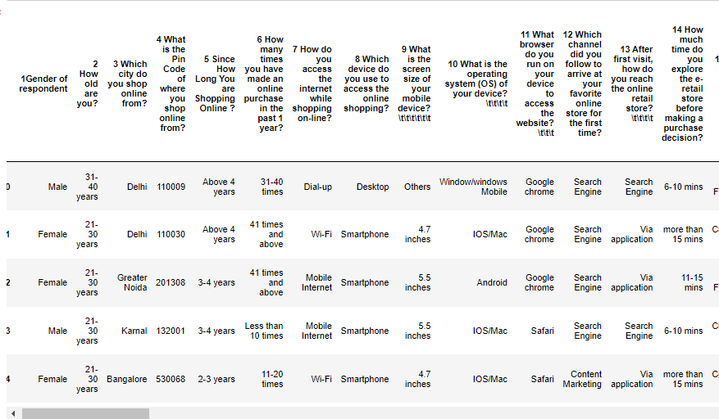

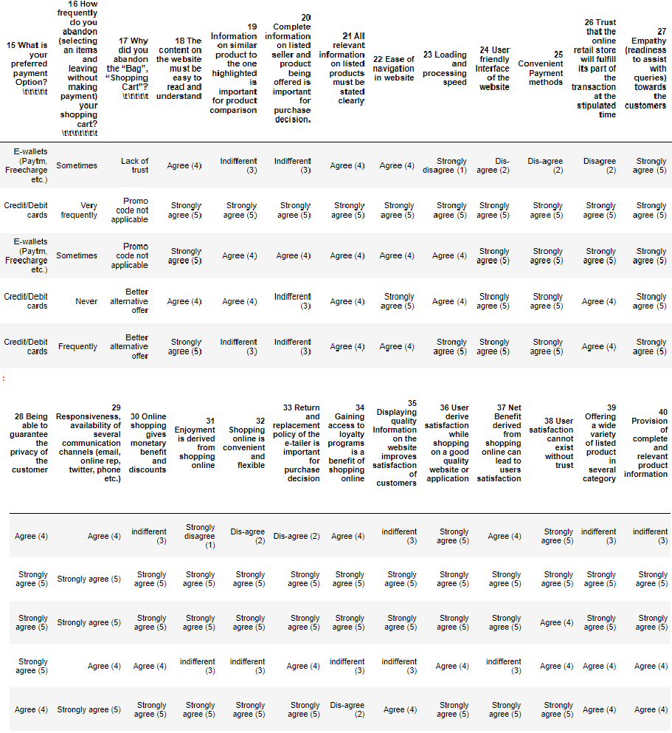

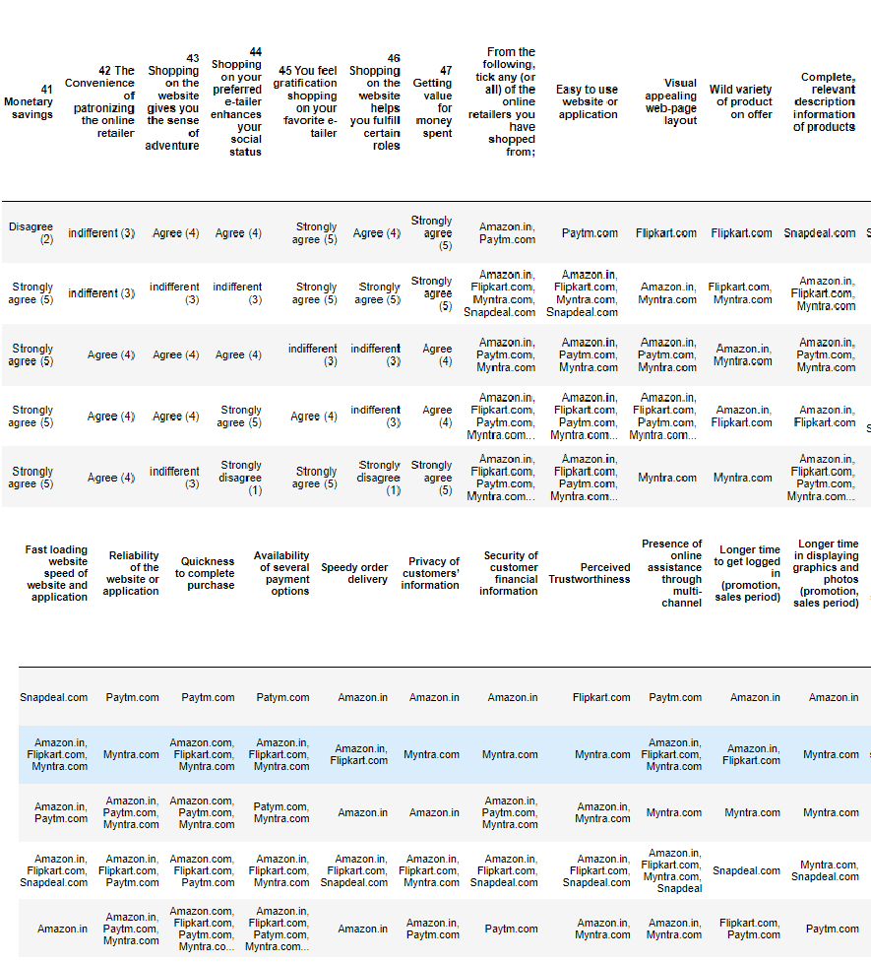

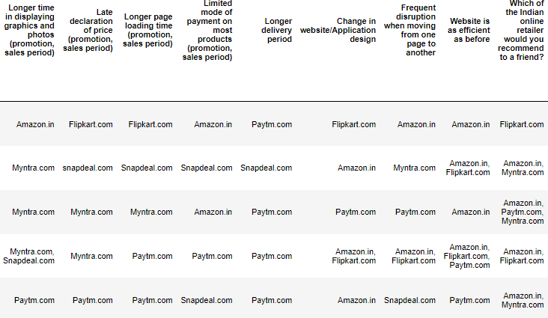

All the variables in the dataset are of object type except Pincode, however it is categorical in nature. The dataset contains 269 rows and 71 columns. The data contains no null value however there is a lot of unwanted characters in the columns.

DATA PREPROCESSING:

* The dataset contains 269 rows and 71 columns.
* There is no null value in the dataset.
* To fix the column problem following command has been used.

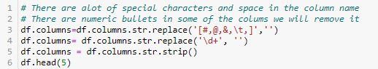

* To encode Label encoder has been used.

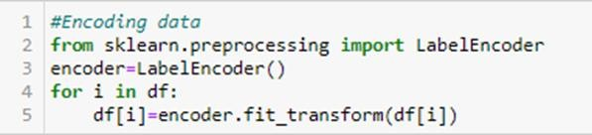

Hardware and Software Requirements and Tools Used

* A mid level computer that runs on Intel i3- i5 8th generation, 4gb ram or A10/A11or any other equivalent chipset and a suitable processor.
* Juypter Notebook/Google chrome
* Libraries and packeges used:

import pandas as pd import numpy as np

import matplotlib.pyplot as plt import seaborn as sn

import warnings warnings.filterwarnings("ignore")

We will use Python through Jupyter notebook for data processing. Also we will use liabraries here is numpy, matplotlib, pandas and seaborn. The matpotplotlib and seaborn library has been used to make charts to visualize and understand the problem, correlation, outliers and many other things, the pandas and numpy library issued to handel dataset and perform various tasks.

**Exploratory Data Analysis:**

**Univariate Analysis:**

*#1.'Genderof respondent'*

sn.catplot(data=df,kind='count',x="Genderofrespondent")

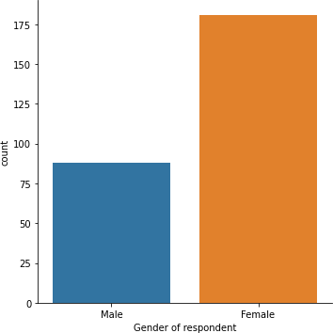

* The female responders are double in number in comparison of Male.

*#2.Howold are you?* sn.catplot(data=df,kind='count',x="Howoldareyou?")plt.xticks(rotatio n=90)

plt.show()

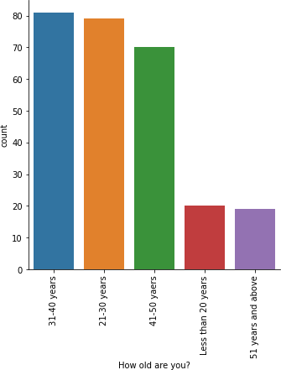

* Majority of respondents are in age group of 20-50
* There are very few respondents above 51 and below 20 years old.

*#3.'Which city do you shop online from?'* sn.catplot(data=df,kind='count',x='Whichcitydoyoushoponlinefrom?')plt.xticks(rota tion=90)

plt.show()

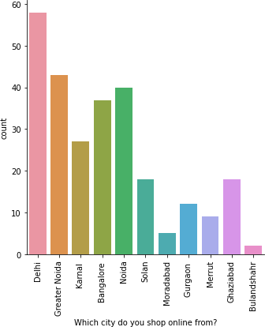

* Delhi is the most prone for online shopping followed by Greater Noida and Noida.
* Moradabad and Bulandshahr has least number of shopers.

*#4.'SinceHowLongYouareShoppingOnline?'* sn.catplot(data=df,kind='count',x="SinceHowLongYouareShoppingOnline?")plt.xticks( rotation=90)

plt.show()

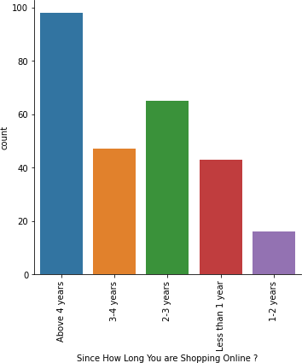

* Majority of people are shopping from more than 4 years.

*#5.How many times you have made an online purchase in the past 1 year?*

sn.catplot(data=df,kind='count',x='Howmanytimesyouhavemadeanonline␣

*‹→*purchaseinthe past

year?')

plt.xticks(rotation=90)

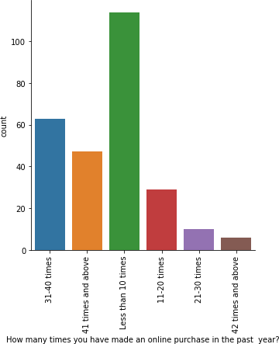

* Majority of the respondents has shopped less than 10 times.
* Very few are frequent buyers.

*#6Howdoyouaccesstheinternetwhileshoppingon-line?*

sn.catplot(data=df,kind='count',x='Howdoyouaccessthe internetwhile␣

*‹→*shoppingon-line?')

plt.xticks(rotation=90) plt.show()

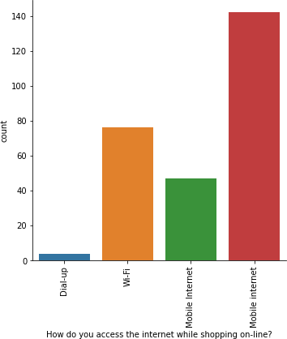

*#As we can see there are two mobile internet column. We will merge them into one*

df.replace(to_replace="Mobileinternet",

value="MobileInternet",inplace=**True**)

*#7.Howdoyouaccesstheinternetwhileshoppingon-line?*

sn.catplot(data=df,kind='count',x='Howdoyouaccessthe internetwhile␣

*‹→*shoppingon-line?')

plt.xticks(rotation=90) plt.show()

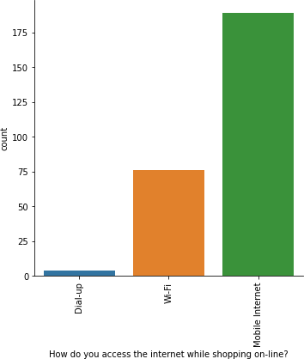

* Approx all the respondents prefer Mobile internet followed by Wifi.
* Dial up net is least preferable.

*#8.Whichdevice do you use to access the online shopping?* sn.catplot(data=df,kind='count',x='Whichdevicedoyouusetoaccesstheonlineshopping?’) plt.xticks(rotation=90)

plt.show()

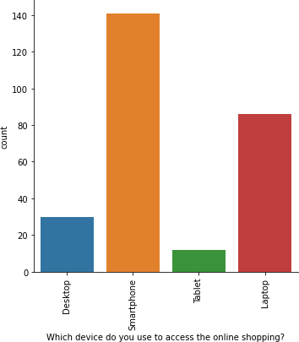

* As we observed earlier that majority of population use Mobile internet so here we can see smartphone is the mostly used.

*#8.What isthe screen size of your mobile device?*

sn.catplot(data=df,kind='count',x='Whatisthescreensizeofyourmobile␣

*‹→*device?')

plt.xticks(rotation=90) plt.show()

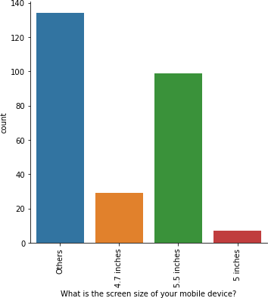

* Majority of the respondents has answered others so in the option the smallest size 4.7 inches.
* We can assume that the others smartphone screensize is more than 5.5inches.

*#9.What is the operating system (OS) of your device?*

sns.catplot(data=df,kind='count',x='Whatisthe operating system(OS)ofyour␣

*‹→*device?')

plt.xticks(rotation=90) plt.show()

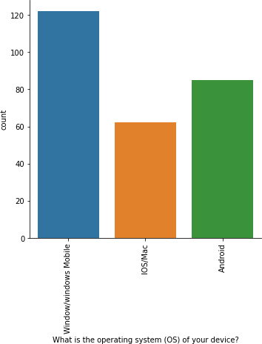

* Windows is the most popular os while IOS/mac is least used.

*#10.What browser do you run on your device to access the website?*

␣

sn.catplot(data=df,kind='count',x='Whatbrowserdoyourunonyourdevicetoaccessthewe bsite?')plt.xticks(rotation=90)

plt.show()

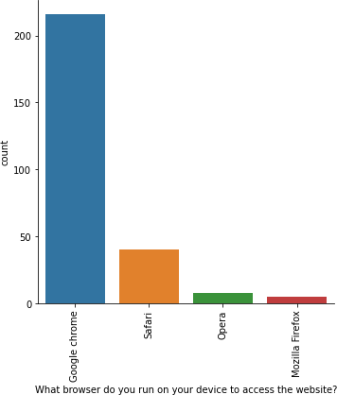

* Approx all respondents uses google chrome for accesing the website.

*#11.Which channel did you follow to arrive at your favorite online store for the*␣

*‹→firsttime?*

sn.catplot(data=df,kind='count',x='Whichchanneldidyoufollowtoarriveat␣

*‹→*yourfavoriteonlinestoreforthefirsttime?')plt.xticks(rotation=90)

plt.show()

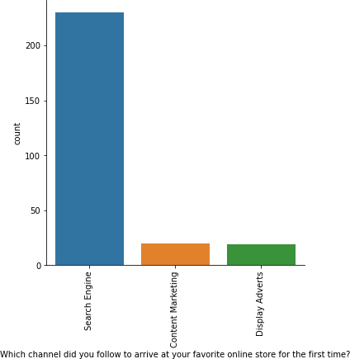

:

*#12.Afterfirstvisit,howdoyoureachtheonlineretailstore?* sn.catplot(data=df,kind='count',x='Afterfirstvisithowdoyoureachtheonlineretailsto re?')

plt.xticks(rotation=90) plt.show()

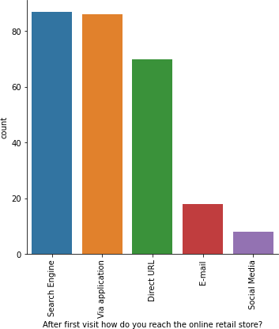

* Most respondents visit the sites by choice as they use search engine to navigate to website instead of clicking on advertisement.

*#13.Howmuchtimedoyouexplorethee-retailstorebeforemakingapurchasedecision* sn.catplot(data=df,kind='count',x='Howmuchtimedoyouexploretheretailstorebeforema kingapurchasedecision?') plt.xticks(rotation=90)

plt.show()

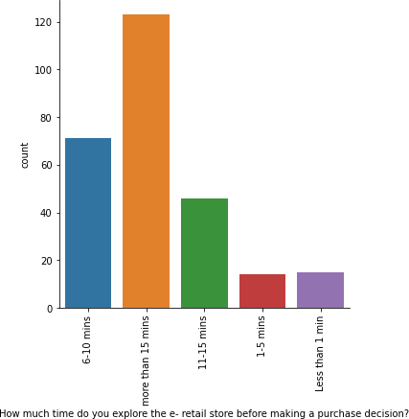

* Majority of the respondents take more than 15 minute to make a purchase decision.
* There are respondents who take less than a minute to arrive on any conclusion*.*

*#13.WhatisyourpreferredpaymentOption?* sn.catplot(data=df,kind='count',x='WhatisyourpreferredpaymentOption?')plt.xticks( rotation=90)

plt.show()

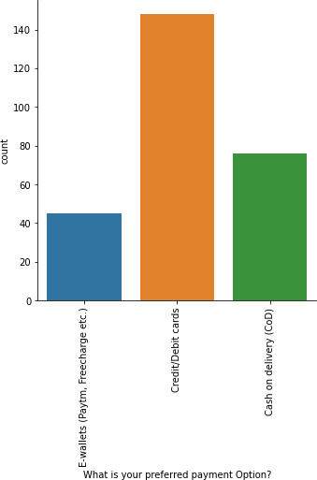

* Credit/debit card is the most used payment method followed by COD

*#14.How frequently do you abandon (selecting an items and leaving without making*␣

*‹→payment) your shopping cart?*

sn.catplot(data=df,kind='count',x='Howfrequentlydoyouabandon(selecting␣

*‹→*anitemsandleavingwithoutmakingpayment)yourshoppingcart?')plt.xti

cks(rotation=90) plt.show()

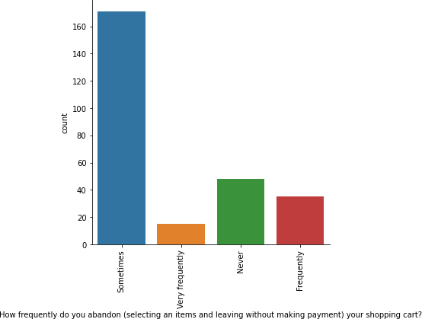

* There are very few respondents who leave after selecting an item.

*#15.Whydid you abandon the “Bag”, “Shopping Cart”?*

sn.catplot(data=df,kind='count',x='Whydidyouabandonthe“Bag”“Shopping␣

*‹→*Cart”?')

plt.xticks(rotation=90) plt.show()

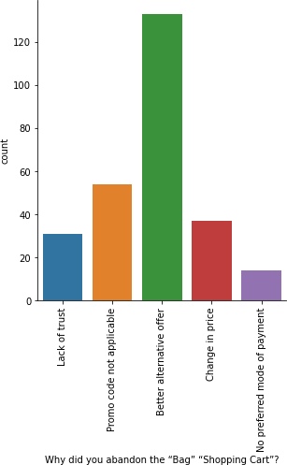

* Most sited reason for leaving added item is that the respondents gets better Alternative offer.
* So we can assume that they check or compare the product with other site also

*#16.Thecontent on the website must be easy to read and understand*

sn.catplot(data=df,kind='count',x='Thecontentonthewebsitemustbeeasy␣

*‹*toreadandunderstand')plt.xtick

s(rotation=90) plt.show()

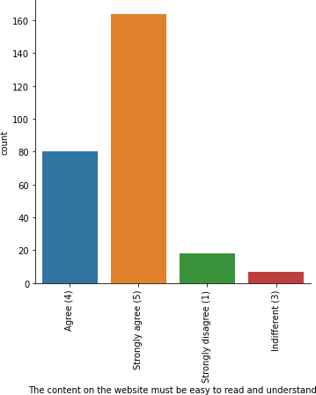

* Respondents like easy to read and understand content.

*#17.Informationonsimilarproducttotheonehighlightedisimportantforproduct comparison'* sn.catplot(data=df,kind='count',x='Informatioonsimilarproducttotheonehighlightisi

mportantforproductcomparison')plt.xticks(rotation=90)

plt.show()

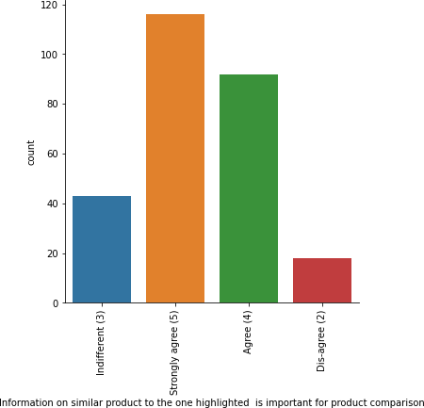

* Side comparison of similar product is more welcoming.

*#18.Completeinformationonlistedsellerandproductbeingofferedisimportant*␣

*‹→forpurchasedecision.*

sn.catplot(data=df,kind='count',x='Completeinformationonlistedselleandproductbein gofferedisimportantforpurchasedecision.')plt.xticks(rotation=90)

plt.show()

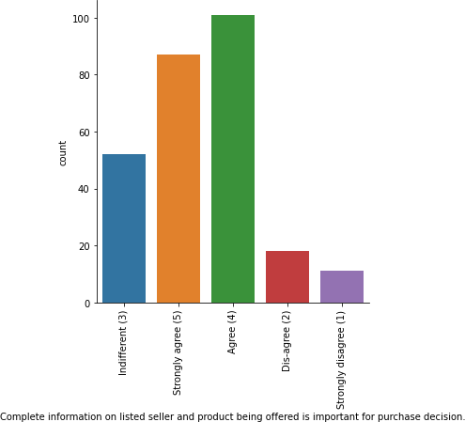

* Complete information about seller and product is necessary.

*#19.Allrelevantinformationonlistedproductsmustbestatedclearly* sn.catplot(data=df,kind='count',x='Allrelevantinformationonlistedproductsmustbe statedclearly')plt.xticks(rotation=90)

plt.show()

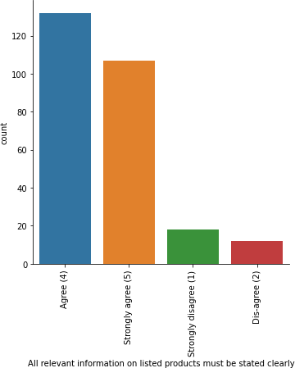

* Respondents expect full transparency on the detail provided about the product on the website.

*#20.Easeofnavigationinwebsite*

sn.catplot(data=df,kind='count',x='Easeofnavigationinwebsite')plt.xticks(rotation

=90)

plt.show()

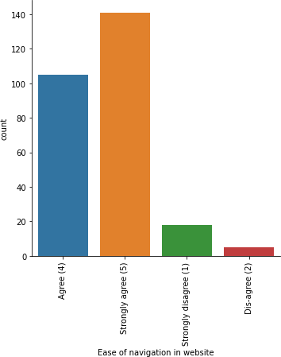

* Website User Interface should be used friendly.

*#21.Loading and processing speed*

sn.catplot(data=df,kind='count',x='Loadingandprocessingspeed')plt.xticks(rotation

=90)

plt.show()

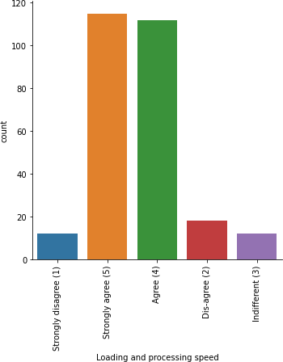

* The loading and processing speed plays a very important role.

*#22.UserfriendlyInterfaceofthewebsite* sn.catplot(data=df,kind='count',x='UserfriendlyInterfaceofthewebsite') plt.xticks(rotation=90)

plt.show()

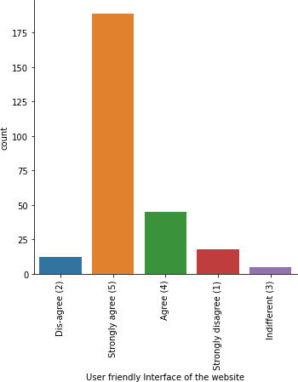

*#23.ConvenientPayment methods* sn.catplot(data=df,kind='count',x='ConvenientPaymentmethods')plt.xticks(r otation=90)

plt.show()

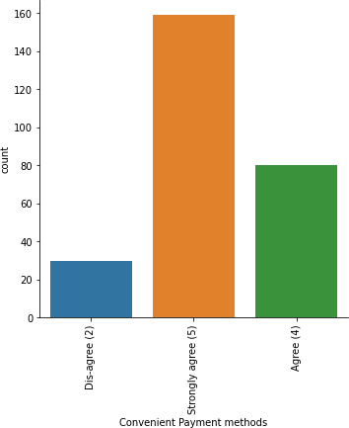

* Respondents prefer convenient methods.

*#23.Trustthattheonlineretailstorewillfulfillitspartofthetransactionatthestipul atedtime* sn.catplot(data=df,kind='count',x='Trustthattheonlineretailstorewillfulfillitspa

rtofthetransactionatthestipulatedtime')plt.xticks(rotation=90)

plt.show()

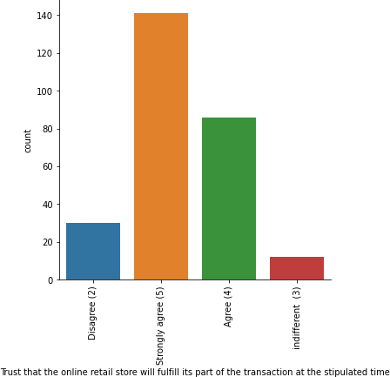

* Respondents trust online sites with transaction.

*#24.Empathy(readinesstoassistwithqueries)towardsthecustomers* sn.catplot(data=df,kind='count',x='Empathy(readinesstoassistwithqueries)towardsth e customers')plt.xticks(rotation=90)

plt.show()

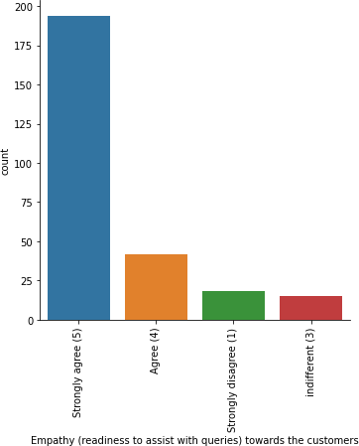

* Customer support plays a very important role according to respondents.

*#25.Beingabletoguaranteetheprivacyofthecustomer* sn.catplot(data=df,kind='count',x='Beingabletoguaranteetheprivacyofthecustomer') plt.xticks(rotation=90) plt.show()

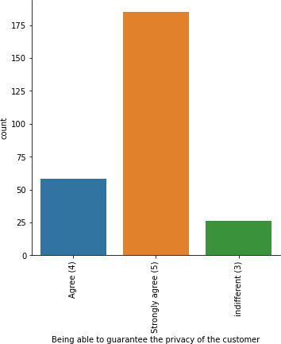

* Privacy is very big concern.

*# 26.Responsiveness, availability of several communication channels (email, online*␣*rep,twitter,phoneetc.)* sn.catplot(data=df,kind='count',x='Responsivenessavailabilityofseveralcommunic ationchannels(emailonlinereptwitterphoneetc.)')plt.xticks(rotation=90) plt.show()

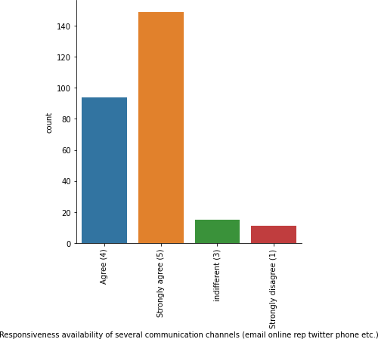

* The more communication channels for the shopper to connect with customer service is a good sign.

*#27.Onlineshoppinggivesmonetarybenefitanddiscounts* sn.catplot(data=df,kind='count',x='Onlineshoppinggivesmonetarybenefitanddiscounts ') plt.xticks(rotation=90) plt.show()

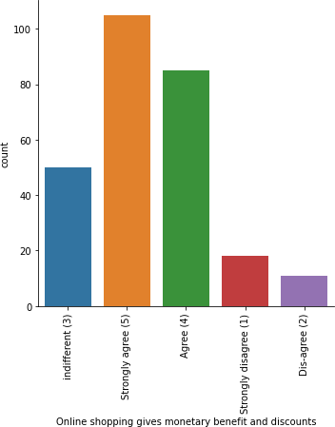

* Respondents belive online shopping gives monetary benefit and discounts.

*#28.Enjoymentisderivedfromshoppingonline* sn.catplot(data=df,kind='count',x='Enjoymentisderivedfromshoppingonline') plt.xticks(rotation=90)

plt.show()

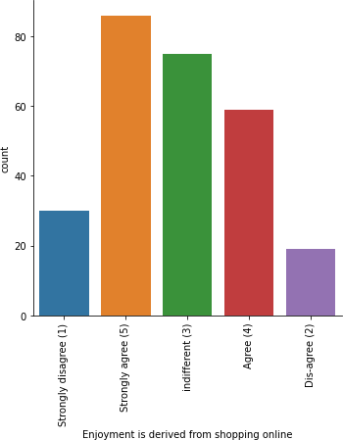

* Online shopping can also be seen as fun activity.

*#29.Shoppingonlineisconvenientandflexible* sn.catplot(data=df,kind='count',x='Shoppingonlineisconvenientandflexible') plt.xticks(rotation=90)

plt.show()

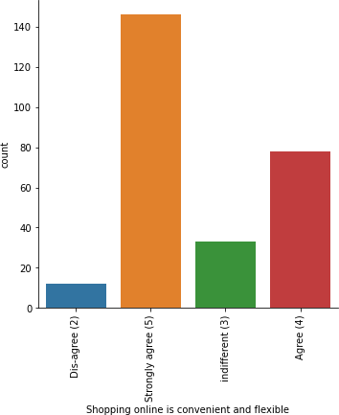

* According to respondents online shopping is very flexible and convenient.

*#30.Returnandreplacementpolicyofthee-tailerisimportantforpurchasedecision* sn.catplot(data=df,kind='count',x='Returnandreplacementpolicyofthetailerisimporta ntforpurchasedecision')plt.xticks(rotation=90)

plt.show()

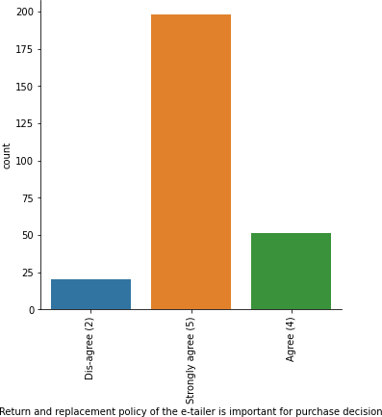

* Return and replacement policy of the e-tailer is important for purchase decision according to the respondents.

*#31.Gainingaccess to loyalty programs isa benefit of shopping online* sn.catplot(data=df,kind='count',x='Gainingaccesstoloyaltyprogramsisabenefitofsho ppingonline')plt.xticks(rotation=90)

plt.show()

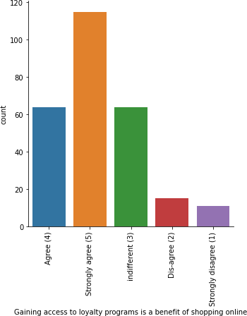

* Loyality program attracts shopper.

*#32.DisplayingqualityInformationonthewebsiteimprovessatisfactionofcustomers* sn.catplot(data=df,kind='count',x='DisplayingqualityInformationonthewebsiteimprov essatisfactionofcustomers')plt.xticks(rotation=90)

plt.show()

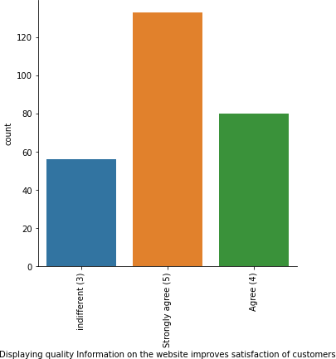

* Detail are important for customer satisfaction.

*#32.Userderive satisfaction while shopping on a good quality website or*␣*application* sn.catplot(data=df,kind='count',x='Userderivesatisfactionwhileshoppingonagoodqua litywebsiteorapplication')plt.xticks(rotation=90)

plt.show()

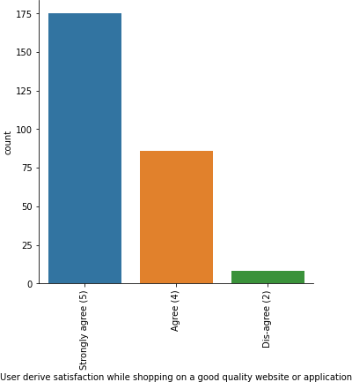

* Quality of website or web application very much affect shoppers.

*#33.Usersatisfactioncannotexistwithouttrust* sn.catplot(data=df,kind='count',x='Usersatisfactioncannotexistwithouttrust') plt.xticks(rotation=90)

plt.show()

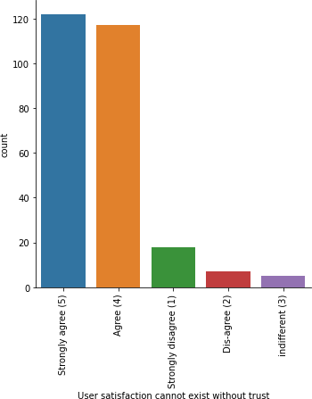

* Trust building is very essential to make shoppers shop online.

*#34.Offeringawidevarietyoflistedproductinseveralcategory* sn.catplot(data=df,kind='count',x='Offeringawidevarietyoflistedproductinseveralca tegory')plt.xticks(rotation=90)

plt.show()

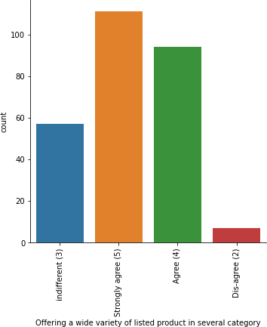

* Shoppers prefer a wide range of products in same category.

*#36.Monetarysavings* sn.catplot(data=df,kind='count',x='Monetarysavings')plt.xticks(rotation=9 0)

plt.show()

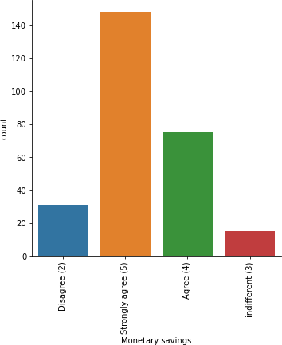

* Respondents agreed that online shopping saves money.

*#37.Shoppingon your preferred e-tailer enhances your social status* sn.catplot(data=df,kind='count',x='Shoppingonyourpreferredetailerenhancesyoursoci alstatus')plt.xticks(rotation=90) plt.show()

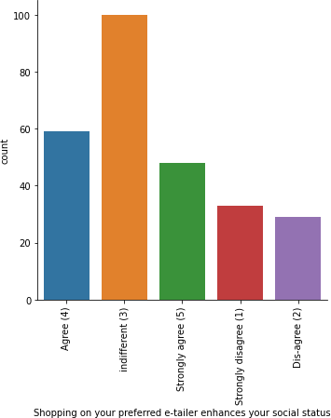

* Respondents belives that shopping on particular websites lead to status symbol.

*#38.Youfeel gratification shopping on your favorite e-tailer* sn.catplot(data=df,kind='count',x='Youfeelgratificationshoppingonyourfavoriteeta iler')plt.xticks(rotation=90) plt.show()

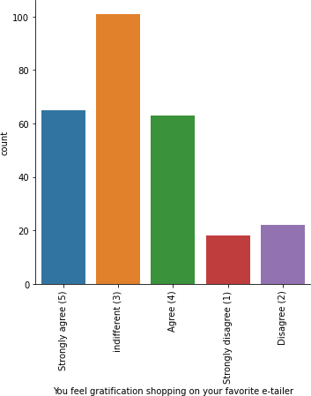

* Shoppers feel satisfied and gratified shopping on their preferred website.

*#39.Gettingvalueformoneyspent*

sn.catplot(data=df,kind='count',x='Gettingvalueformoneyspent')plt.xticks(rotation

=90)

plt.show()

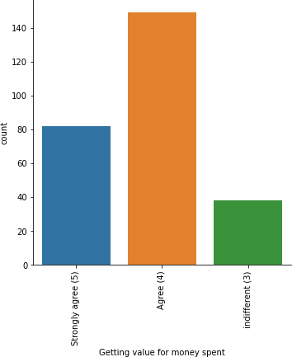

* Respondents agree that they get value for money product.

*#40.Fromthefollowing,tickany(orall)oftheonlineretailersyouhaveshoppedfrom*

plt.figure(figsize=(15,10)) sn.countplot(data=df,x='Fromthefollowingtickany(orall)oftheonlineretailersyouhave shoppedfrom;')plt.xticks(rotation=90)

plt.show()

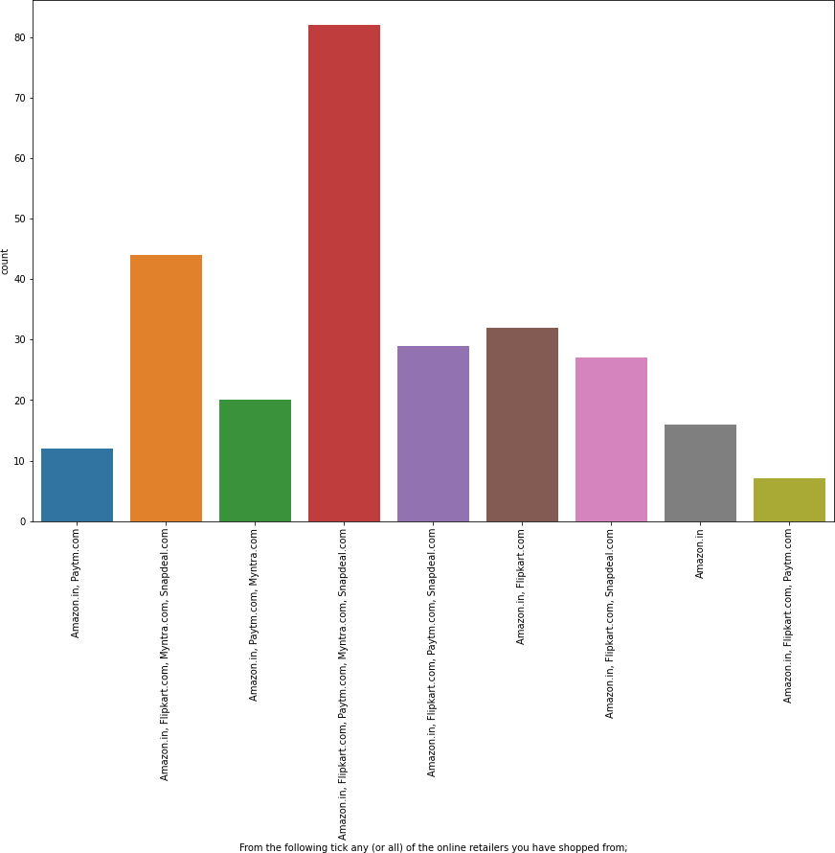

* Most of the respondents used Amazon, Flipkart, Paytm, Myntra , Snapdeal for shopping.

*#41.Easyto use website or application* sn.catplot(data=df,kind='count',x='Easytousewebsiteorapplication')plt.xticks(rota tion=90)

plt.show()

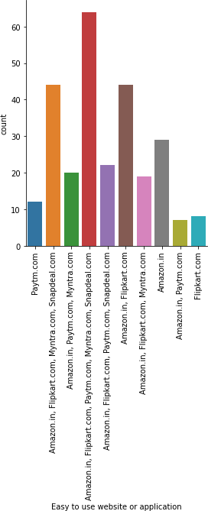

80

* Most of the respondents agree that Amazon, Flpkart, Paytm, myntra, Snapdeal has easy to use application

*#42Visualappealingweb-pagelayout* sn.catplot(data=df,kind='count',x='Visualappealingweb- pagelayout')plt.xticks(rotation=90)

plt.show()

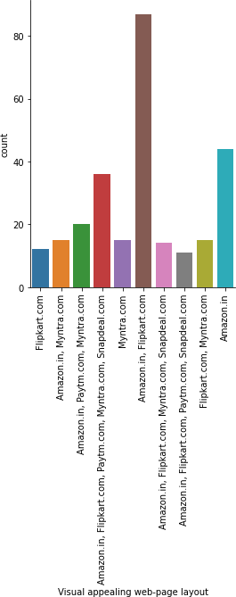

* Amazon and flipkart has most appealing web layout

*#42.Wildvariety of product on offer* sn.catplot(data=df,kind='count',x='Wild varietyofproductonoffer')plt.xticks(rotation=90)

plt.show()

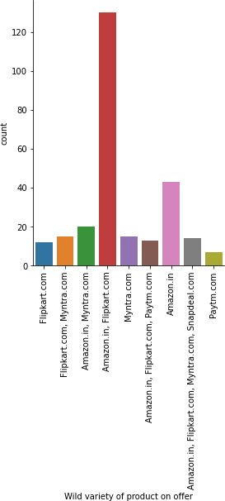

* Amazon and flipkart provides a wide variety of products in comparison of others.

*#42.Complete,relevantdescriptioninformationofproducts* sn.catplot(data=df,kind='count',x='Completerelevantdescriptioninformationofprodu cts') plt.xticks(rotation=90) plt.show()

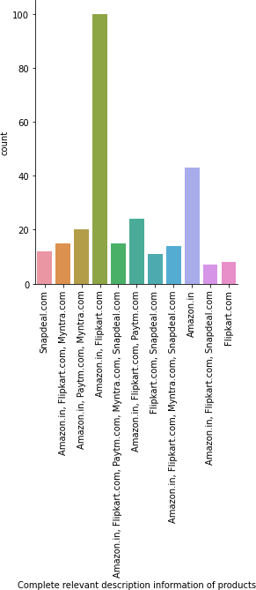

86

* Amazon and flipkart provides complete and relevant information.
* Individually Amazon has more complete and relevant description information of products

*#42.Fastloading website speed of website and application* sn.catplot(data=df,kind='count',x='Fastloadingwebsitespeedofwebsiteandapplication ')

plt.xticks(rotation=90) plt.show()

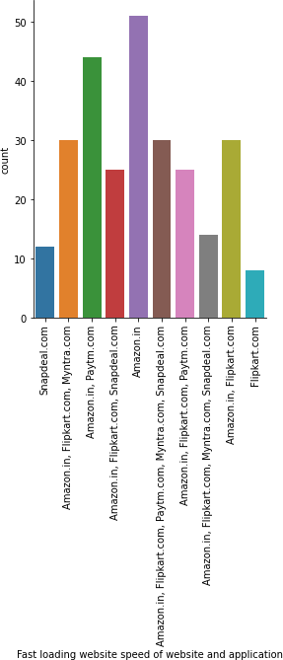

* Amazon is the best website in term of fast loading.

*#43.Reliabilityof the website or application* sn.catplot(data=df,kind='count',x='Reliabilityofthewebsiteor application')

plt.xticks(rotation=90) plt.show()

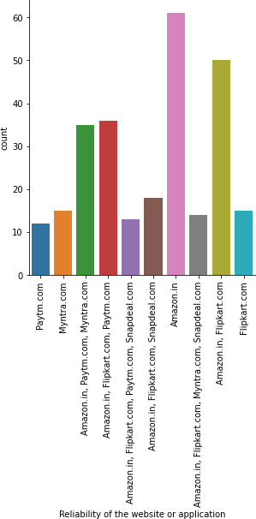

* According to respondents amazon is most trustworthy website.

*#44.Quicknessto complete purchase* sn.catplot(data=df,kind='count',x='Quicknesstocompletepurchase')plt.xticks(rotati on=90)

plt.show()

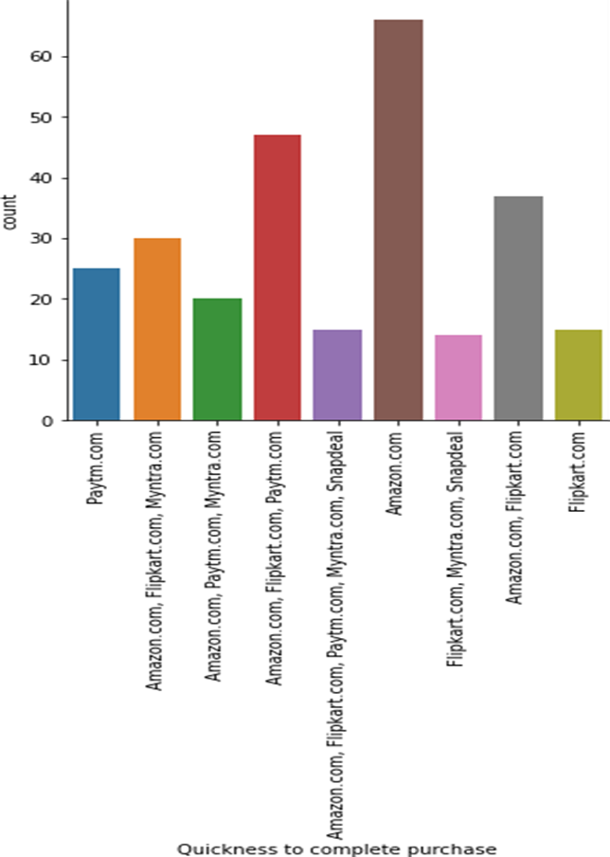

* AMAZON provide faster checkout performance in comparison of others.

*#45.Availabilityofseveralpaymentoptions* sn.catplot(data=df,kind='count',x='Availabilityofseveralpaymentoptions')plt.xtick s(rotation=90)

plt.show()

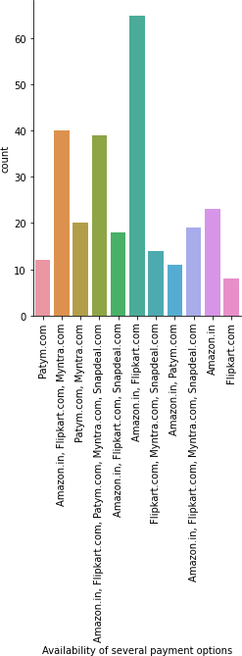94

* According to customer Amazon and Flipkart provides a wide variety of payment methods.

*#46.Speedyorderdelivery* sn.catplot(data=df,kind='count',x='Speedyorderdelivery')plt.xticks(rotation=90) plt.show()

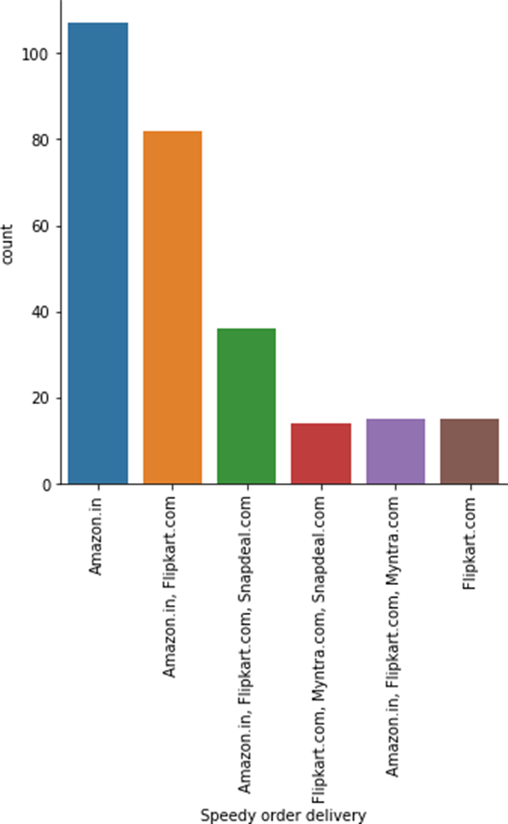

* Amazon provide most speedy experience in comparison of others platforms.

*#47.Privacyofcustomers’information* sn.catplot(data=df,kind='count',x='Privacyofcustomers’information')plt.xticks(rot ation=90)

plt.show()

1

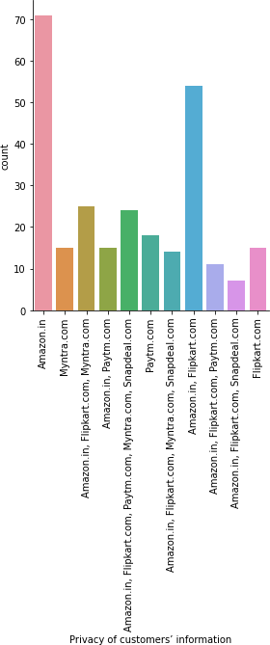

9

* According to respondents Amazon is trusted with privacy in comparison with other platforms.

1

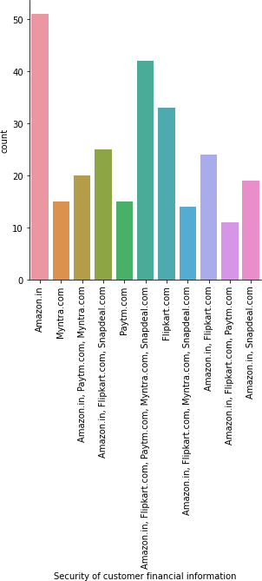

*#48.Securityofcustomerfinancialinformation* sn.catplot(data=df,kind='count',x='Securityofcustomerfinancialinformation') plt.xticks(rotation=90)

plt.show()

* Amazon is trusted by respondents followed by flipkart with security of customers financial information.

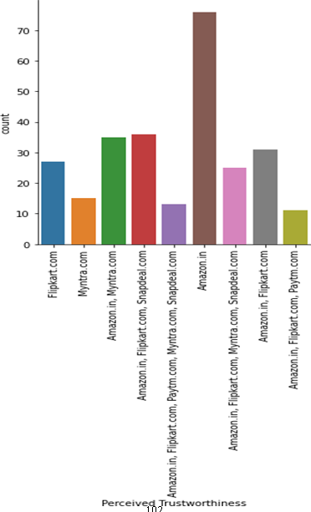

*#48.PerceivedTrustworthiness* sn.catplot(data=df,kind='count',x='PerceivedTrustworthiness')plt.xticks(r otation=90)

plt.show()

* Amazon is most trustworthy website according to customer.

*#49.Presenceofonlineassistancethroughmulti-channel* sn.catplot(data=df,kind='count',x='Presenceofonlineassistancethroughmulti- channel')

plt.xticks(rotation=90) plt.show()

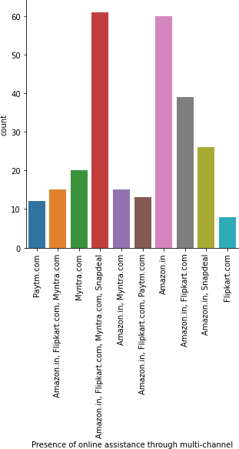

* Amazon provide customer care through multi channel.

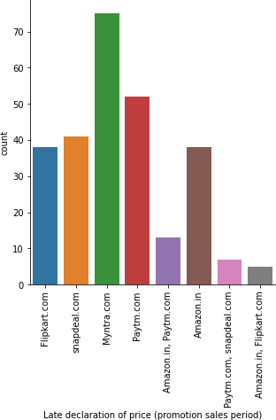

*#50.Latedeclarationofprice(promotion,salesperiod)* sn.catplot(data=df,kind='count',x='Latedeclarationofprice(promotionsalesperiod)') plt.xticks(rotation=90) plt.show()

* Myntra takes longest time to disclose the price or promotion period.

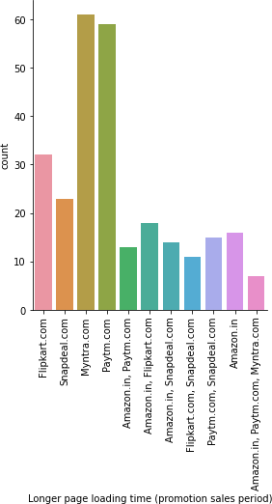

*#51.Longerpageloadingtime(promotion,salesperiod)* sn.catplot(data=df,kind='count',x='Longerpageloading time(promotionsalesperiod)') plt.xticks(rotation=90)

plt.show()

* Myntra takes a lot of time to load its pages followed by Paytm,
* Amazon loads pages fast.

*#52.Limitedmode of payment on most products (promotion, sales period)* sn.catplot(data=df,kind='count',x='Limitedmodeofpaymentonmostproducts(promotionsa lesperiod)')plt.xticks(rotation=90) plt.show()

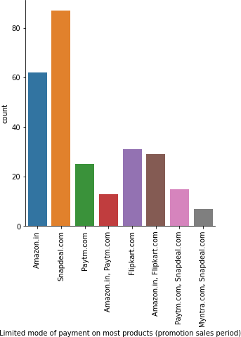

* Snapdeal has very limited payment method in promotion and sales period.

*#53Changeinwebsite/Applicationdesign* sn.catplot(data=df,kind='count',x='Changeinwebsite/Applicationdesign')plt.xticks( rotation=90)

plt.show()

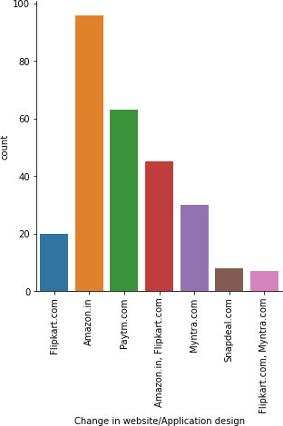

* Amazon changes its website and application design more frequently followed by Paytm.
* Snapdeal changes its design very less

*#54.Websiteisasefficientasbefore* sn.catplot(data=df,kind='count',x='Websiteisasefficientasbefore')plt.xticks(rotat ion=90)

plt.show()

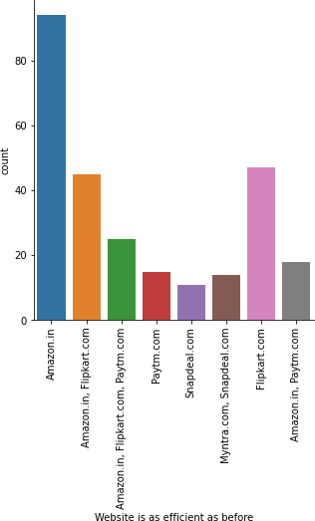

* According to respondents Amazon website is most efficient followed by flipkart
* Snapdeal has least efficient website.

*#54.Whichof the Indian online retailer would you recommend to a friend?* sn.catplot(data=df,kind='count',x='WhichoftheIndianonlineretailerwouldyourecommen dtoafriend?')plt.xticks(rotation=90) plt.show()

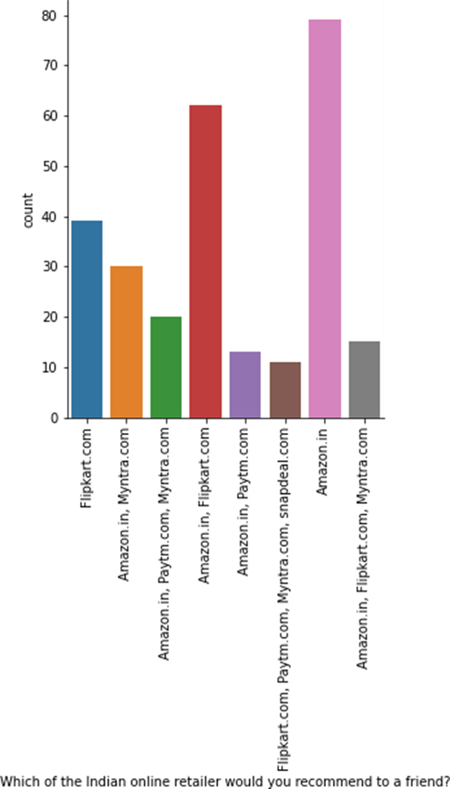

* Amazon is the most recommended website by there respondents followed by flipkart.

### Bivariate Analysis

*#hue=Which of the Indian online retailer would you recommend to a friend?*

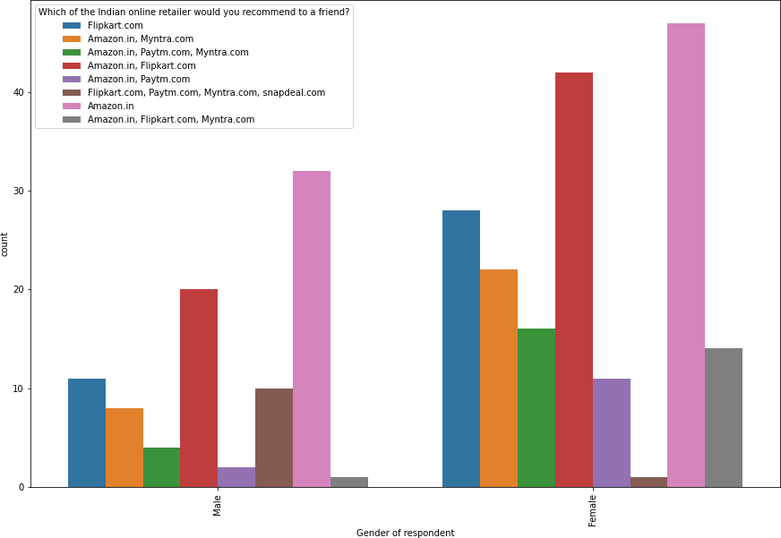

*#Gender of respondent*

plt.figure(figsize=(10,10)) sn.countplot(x="Genderofrespondent",hue="Whichofthe Indianonline␣

*‹→*retailerwouldyourecommendtoafriend?",data=df)plt.xticks(r

otation=90) plt.show()

* Flipkart is more popular among female users.
* Female use more multi platforms for shopping than male.

*#Howold are you?*

plt.figure(figsize=(10,10)) sn.countplot(x="Howoldareyou?",hue="Whichofthe Indianonlineretailer␣

*‹→*wouldyourecommendtoafriend?",data=df)

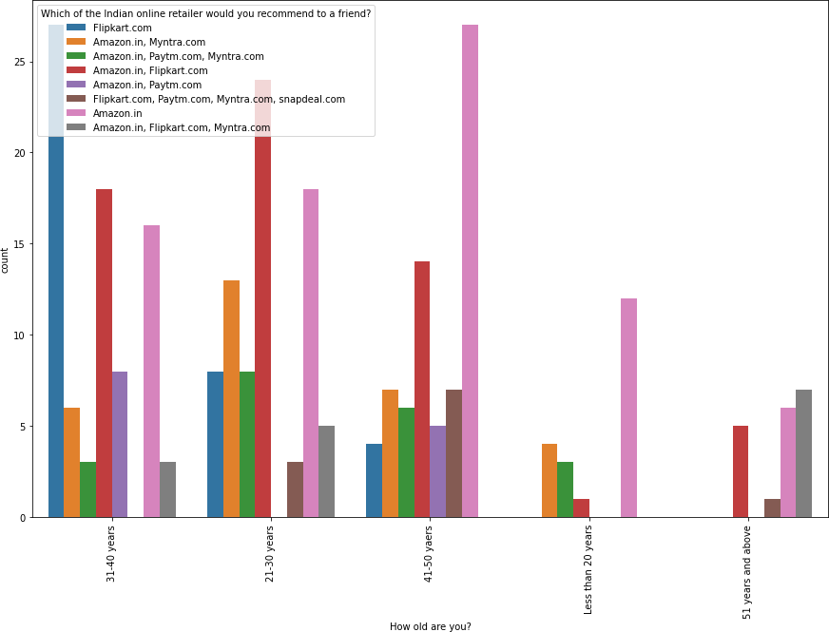

* Flipkart is more popular among age group of 31-40 years people
* Amazon is recommended by all age group people.

*#Whichcitydoyoushoponlinefrom?*

plt.figure(figsize=(10,15)) sn.countplot(x="Whichcitydoyoushoponlinefrom?",hue="WhichoftheIndianonlineretaile rwouldyourecommendtoafriend?",data=df)plt.xticks(rotation=90)

plt.show()

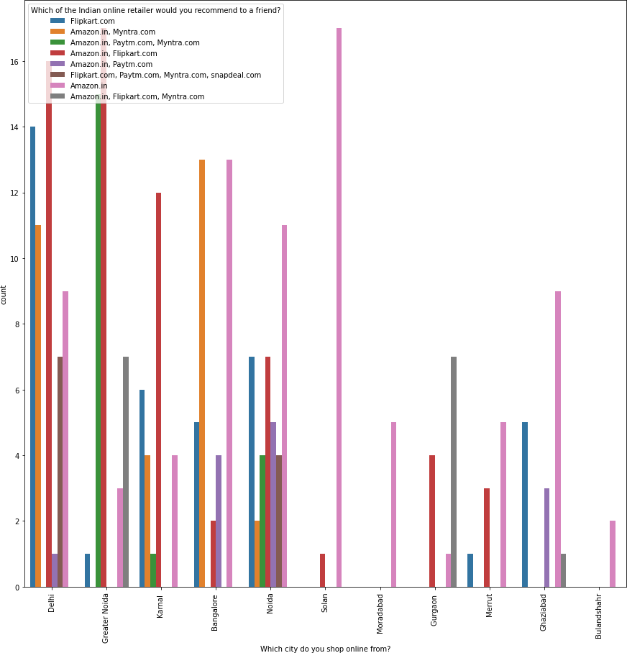

* Amazon is preferred from users of all mentioned city
* Flipkart is mostly use in metropolitan city .
* Banglore and Delhi uses of Myntra.

*#Pincode/city*

df_plot=df.groupby(['Whichcitydoyoushoponlinefrom?','Whatisthe Pin␣

*‹→*Codeofwhereyoushoponlinefrom?']).size().reset_index().

*‹→*pivot(columns='Whatisthe PinCodeofwhereyoushoponlinefrom?',␣

*‹→*index='Whichcitydoyoushoponlinefrom?',values=0)

df_plot.plot(kind='barh',stacked=**True**,figsize=(10,10),colormap="Set3",)plt.legen d(loc="lowerright",bbox_to_anchor=(2.3,.15),ncol=2)

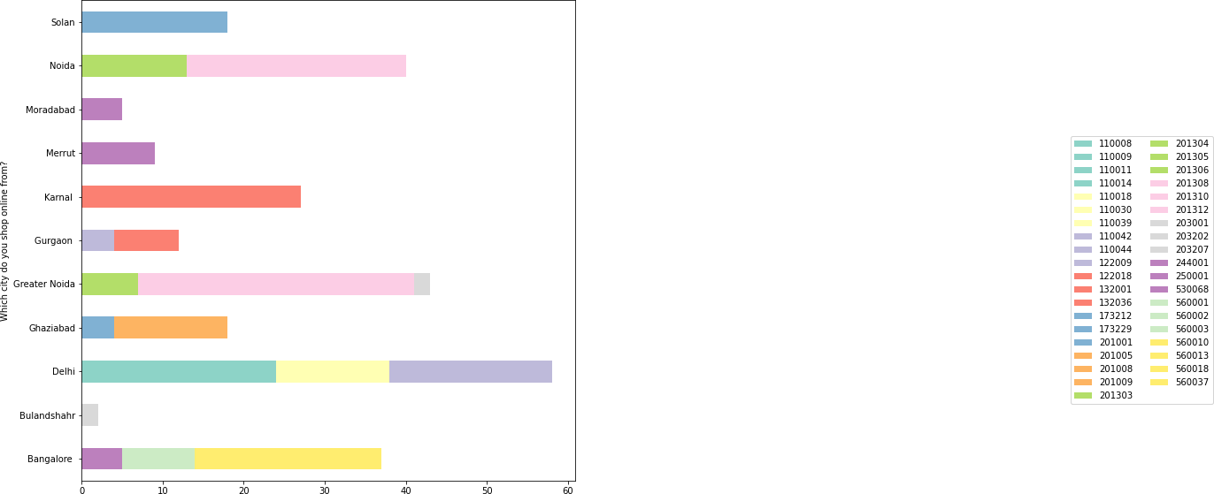

plt.show()

*#Since How Long You are Shopping Online ?*

plt.figure(figsize=(10,10)) sn.countplot(x="SinceHowLongYouareShoppingOnline?",hue="WhichoftheIndianonlineret ailerwouldyourecommendtoafriend?",data=df)plt.xticks(rotation=90)

plt.show()

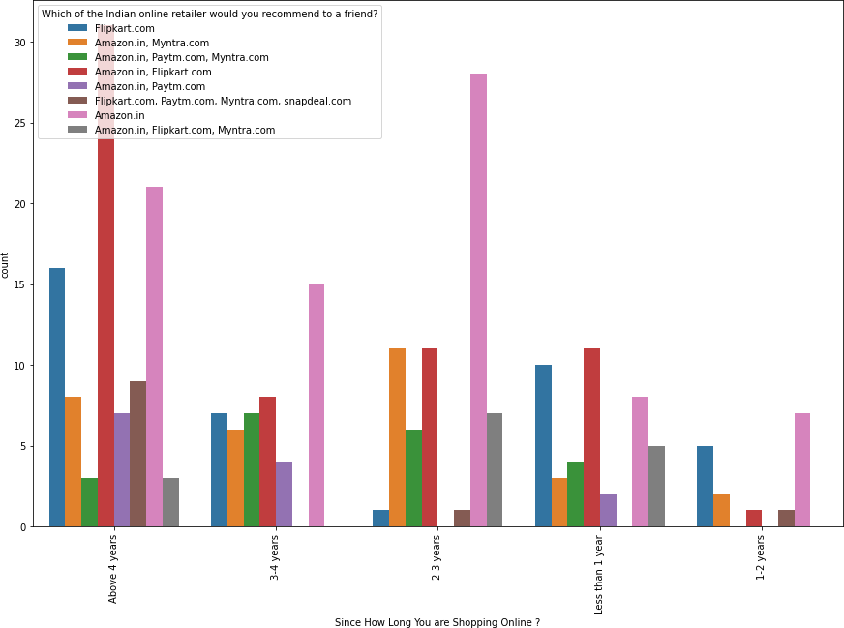

* People who is shopping for more than 4 years is recommending many platforms whole new users mostly recommend amazon or flipkart.

*#How many times you have made an online purchase in the past 1 year?*

plt.figure(figsize=(10,10)) sn.countplot(x="Howmanytimesyouhavemadeanonlinepurchaseinthepastyear?",hue="Which ofthe Indianonlineretailerwouldyourecommendtoafriend?",data=df) plt.xticks(rotation=90)

plt.show()

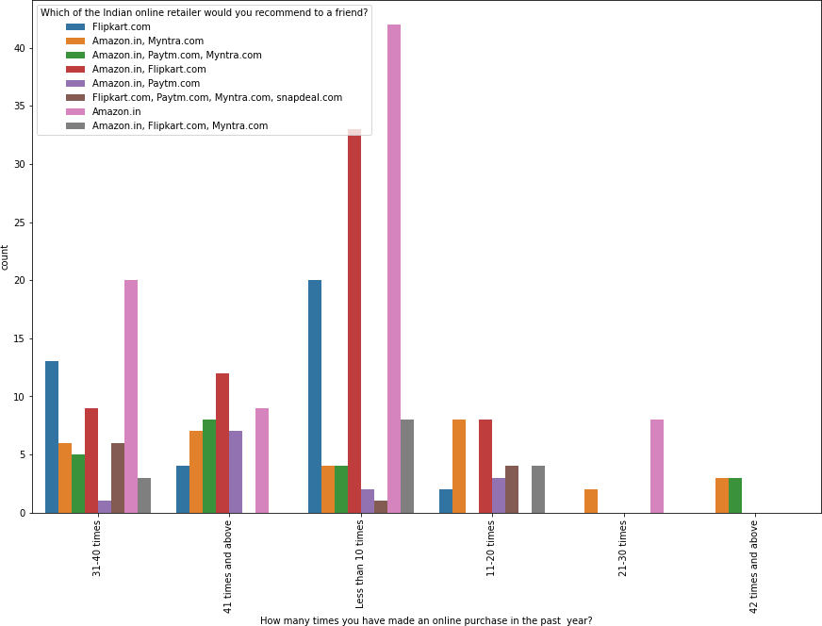

* The most frequent shoppers uses(Amazon/Myntra/Paytm)for shopping.
* Amazon is mostly used for frequents shopping.

*#How doyouaccesstheinternetwhileshoppingon-line?*

plt.figure(figsize=(15,10)) sn.countplot(x="Howdoyouaccesstheinternetwhileshoppingon-line?",␣ hue="WhichoftheIndianonlineretailerwouldyourecommendtoafriend?",data=df) plt.xticks(rotation=90)

plt.show()

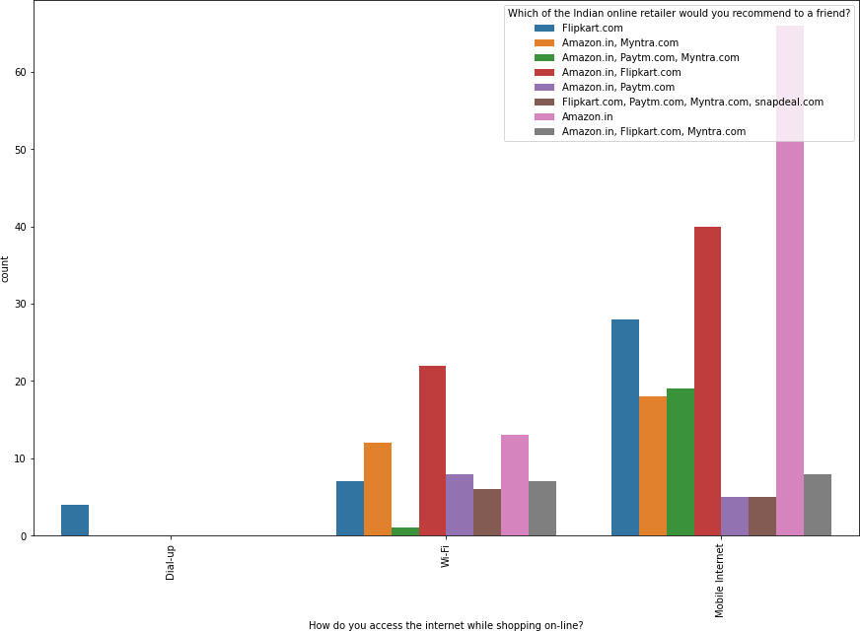

* + People with Dial up connection only suggest flipkart for the shopping.
  + Shoppers with mobile internet is very fond of Amazon followed by flipkart.

*#Whichdevice do you use to access the online shopping?*

plt.figure(figsize=(10,10)) sn.countplot(x="Whichdevicedoyouusetoaccessthe onlineshopping?",␣ hue="Whichofthe Indianonlineretailerwouldyourecommendtoafriend?",data=df) plt.xticks(rotation=90)

plt.show()

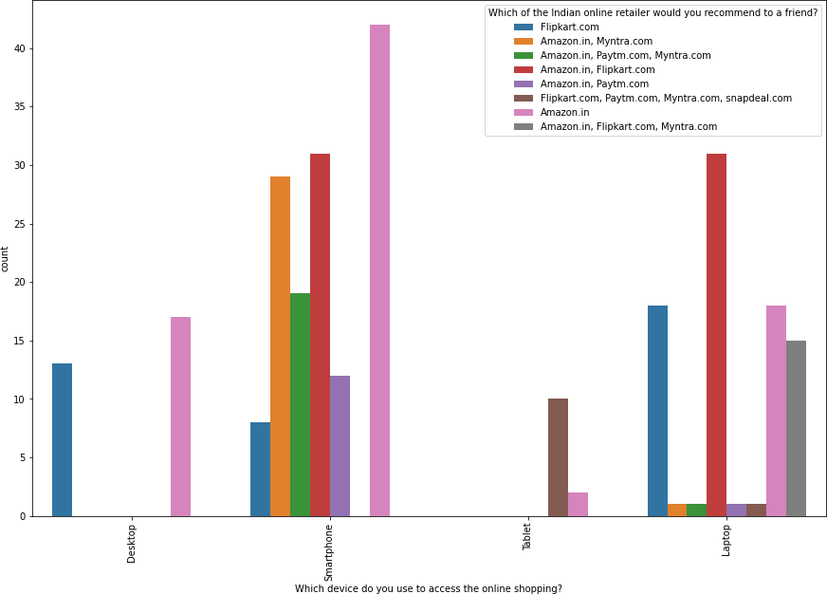

* Desktop users only recommends Flipkart and Amazon .
* Smartphones recommends multiple platforms.

*#What isthe operating system (OS) of your device?*

plt.figure(figsize=(10,10))

sn.countplot(x="Whatistheoperating system(OS)ofyourdevice?",hue="Whichofthe Indianonlineretailerwouldyourecommendtoafriend?",data=df)plt.xticks(rotation=90) plt.show()

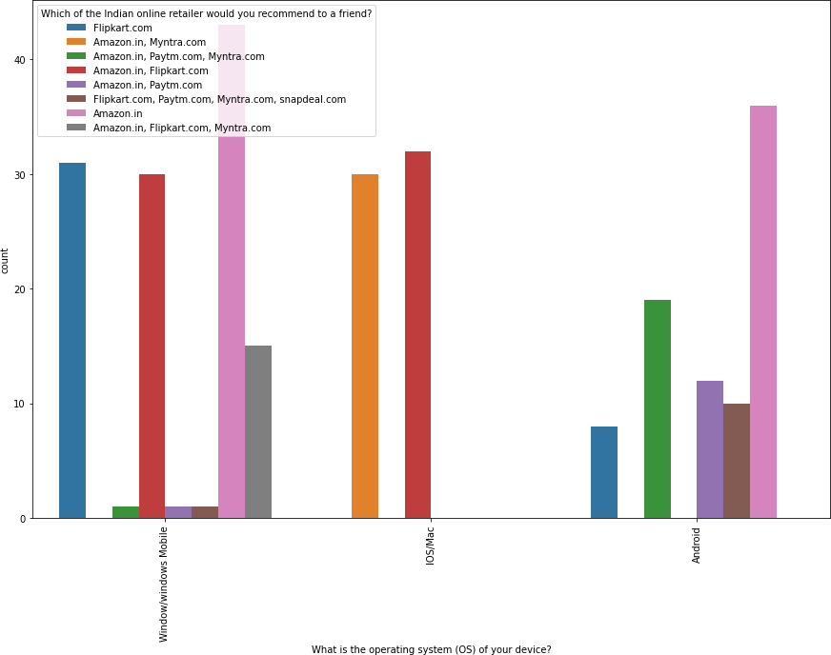

* IOS/Mac users recommends limited platforms(Amazon/Flipkart/Myntra)

*#Whatbrowser do you run on your device to access the website?*

plt.figure(figsize=(10,10)) sn.countplot(x="Whatbrowserdoyourunonyourdevicetoaccessthewebsite?,hue="Whichofth e Indianonlineretailerwouldyourecommendtoafriend?",data=df) plt.xticks(rotation=90)

plt.show()

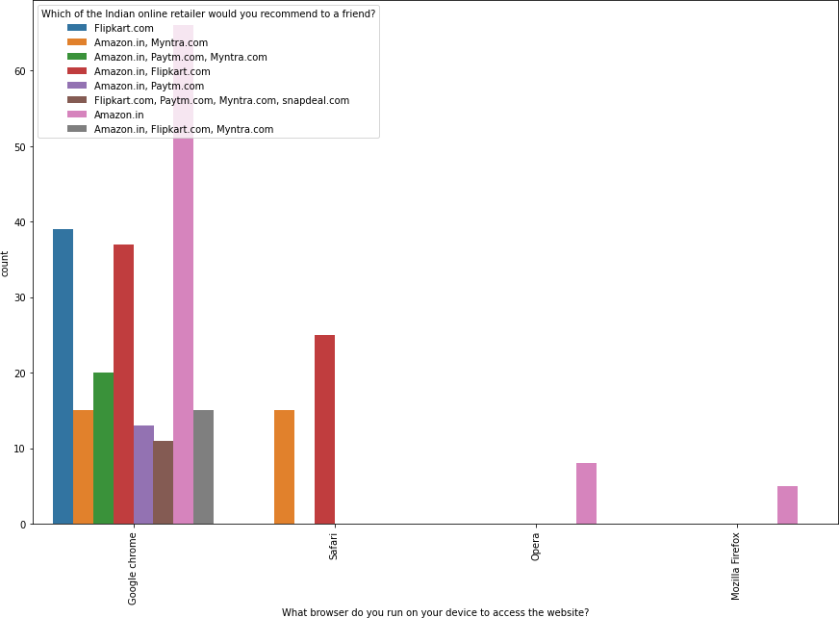

* Chrome is open to many shopping platforms.

*#How much time do you explore the e- retail store before making a purchasedecision?*

plt.figure(figsize=(10,10)) sn.countplot(x="Howmuchtimedoyouexploretheeretailstorebeforemakingapurchasedecisi on?",hue="WhichoftheIndianonlineretailerwouldyourecommendtoafriend?",data=df)plt. xticks(rotation=90)

plt.show()

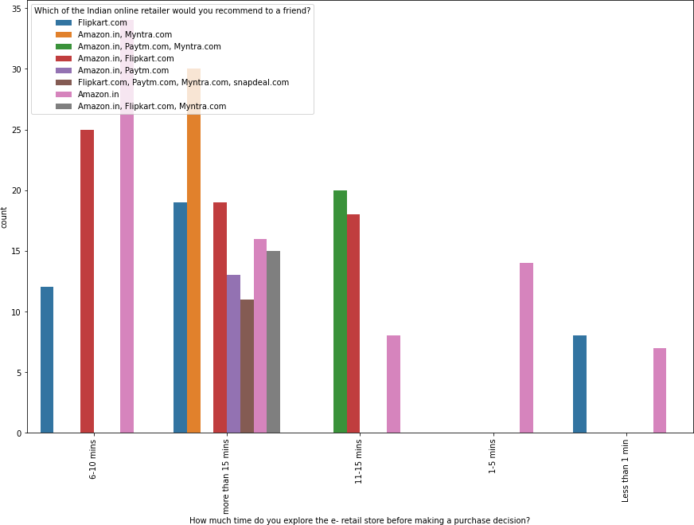

* Amazon/flipkart is the website where users take very less to make a␣

Purchase decision.

* Respondents who takes more time is pron eto explore multiple platforms

*#WhatisyourpreferredpaymentOption?*

plt.figure(figsize=(10,10)) sn.countplot(x="WhatisyourpreferredpaymentOption?",hue="WhichoftheIndianonlineret ailerwouldyourecommendtoafriend?",data=df)plt.xticks(rotation=90)

plt.show()

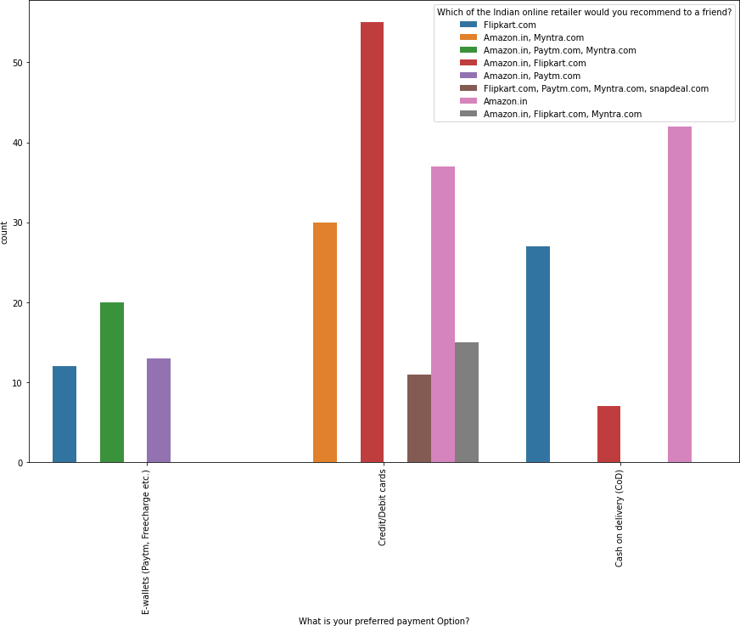

* Amazon and Flipkart is only preferred COD option.

*#The content on the website must be easy to read and understand*

plt.figure(figsize=(10,10)) sn.countplot(x="Thecontentonthewebsitemustbeeasytoreadandunderstand",hue="Whichof the Indianonlineretailerwouldyourecommendtoafriend?",data=df) plt.xticks(rotation=90)

plt.show()

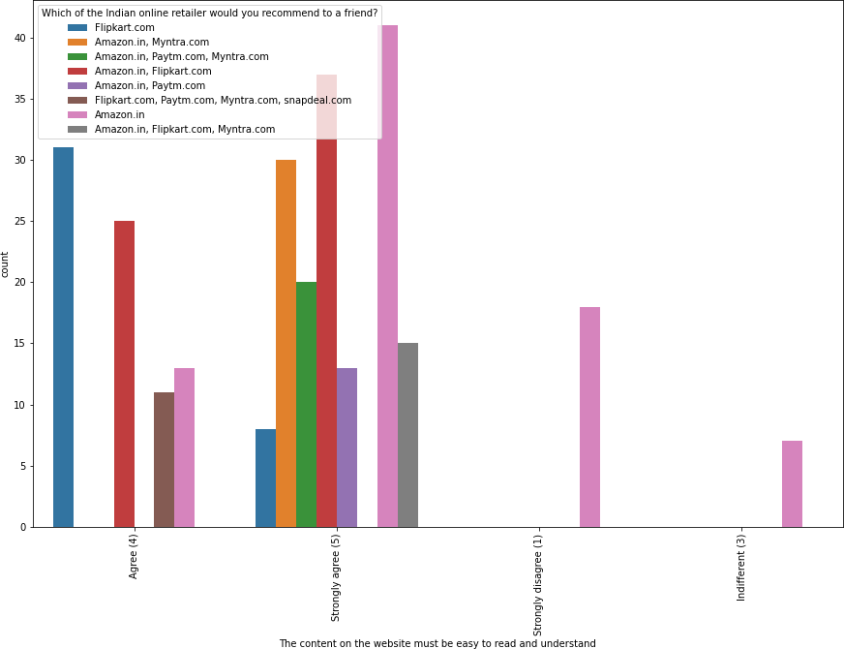

* Respondents suggest flipkart content is very easy to read and understand.

*#Informationonsimilarproducttotheonehighlighteisimportantforproductcomparison*

plt.figure(figsize=(10,10)) sn.countplot(x="Informationonsimilarproducttothonehighlightedisimportantforprodu ctcomparison",hue="WhichoftheIndianonlineretailerwouldyourecommendtoafriend?",dat a=df)plt.xticks(rotation=90)

plt.show()

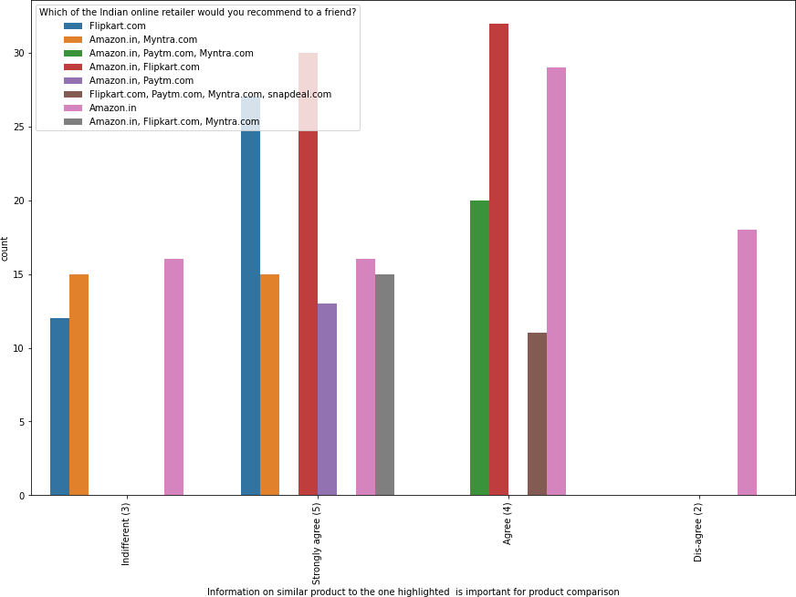

* flipkart and amazon has option for information on similar product to the one highlighted is important for product comparison

*#Completeinformationonlistedsellerandproductbeingofferedisimportantforpurchas edecision.*

plt.figure(figsize=(10,10)) sn.countplot(x='Completeinformationonlistedsellerandproductbeingofferedisimporta ntforpurchasedecision.',hue="WhichoftheIndianonlineretailerwouldyourecommendtoafri end?",data=df)plt.xticks(rotation=90)

plt.show()

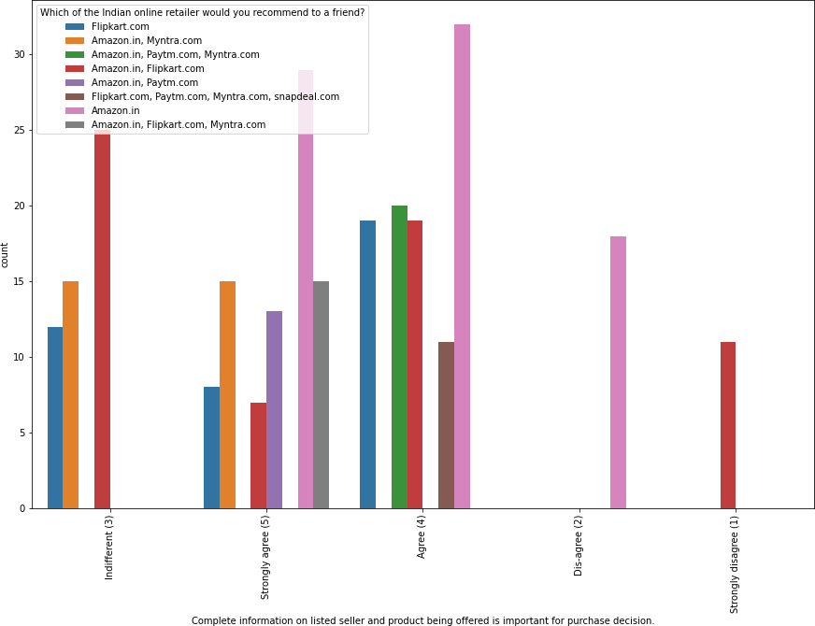

* Amazon is suggest as complete information on listed sellerand product being offered is important for purchase decision.

*#Allrelevantinformationonlistedproductsmustbestatedclearly*

plt.figure(figsize=(10,10)) sn.countplot(x="Allrelevantinformationonlistedproductsmustbestatedclearly",hue=" Whichofthe Indianonlineretailerwouldyourecommendtoafriend?",data=df) plt.xticks(rotation=90)

plt.show()

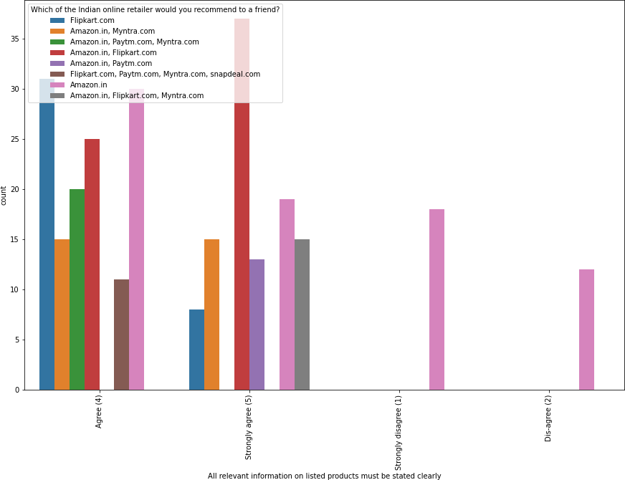

* Respondents suggest amazon and flipkart has all the relevant information on listed products must be stated clearly.

*#Loading and processing speed*

plt.figure(figsize=(10,10)) sn.countplot(x="Loadingandprocessingspeed",hue="WhichoftheIndianonlineretailerwo uldyourecommendtoafriend?",data=df)plt.xticks(rotation=90)

plt.show()

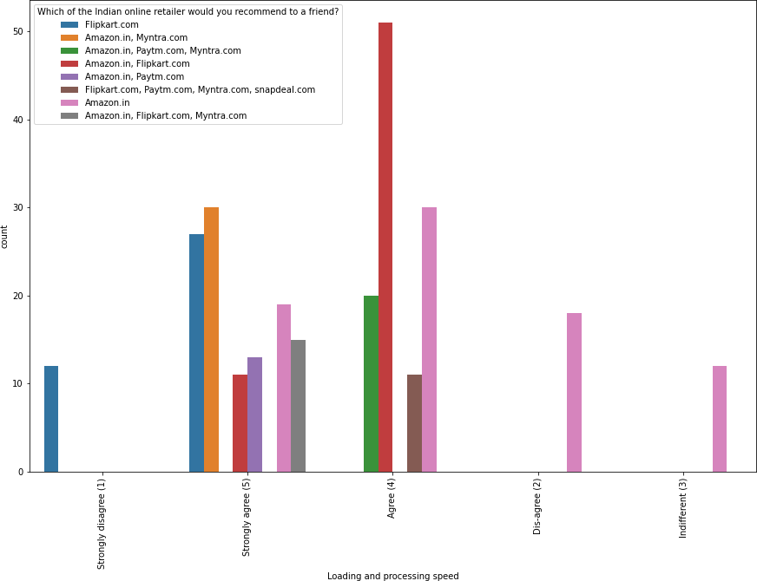

* Respondents who agree with loading speed matters mostly recommends Flipkart/Amazon/Myntra

*#User friendly Interface of the website*

plt.figure(figsize=(10,10)) sn.countplot(x="UserfriendlyInterfaceofthewebsite",hue="WhichoftheIndianonlineret ailerwouldyourecommendtoafriend?",data=df)plt.xticks(rotation=90)

plt.show()

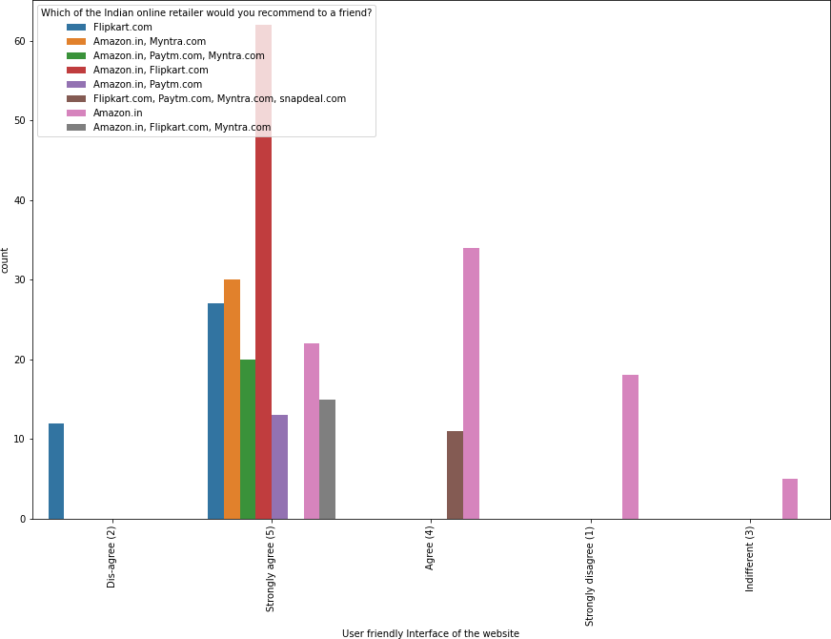

* According to the suggestion Amazon/Flipkart has some more user friendly interface of the website.

*#Convenient Payment methods*

plt.figure(figsize=(10,10)) sn.countplot(x="ConvenientPaymentmethods",hue="WhichoftheIndianonlineretailerwoul dyourecommendtoafriend?",data=df)plt.xticks(rotation=90)

plt.show()

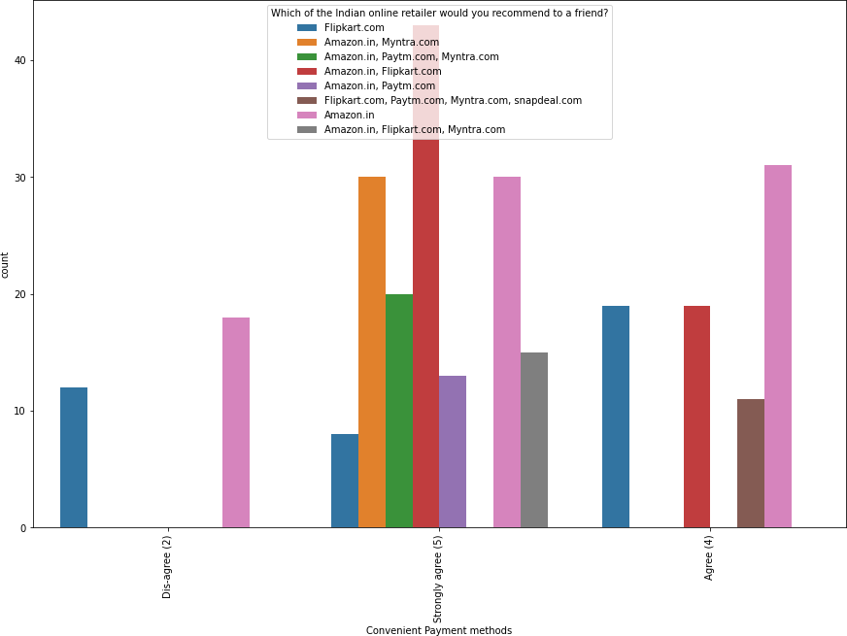

* Amazon/Flipkart/Myntra has recommended on the ases of ease of payment.

*#Trustthattheonlineretailstorewillfulfillitspartofthetransactionatthestipulate dtime*

plt.figure(figsize=(10,10)) sn.countplot(x="Trustthattheonlineretailstorewillfulfillitspartofthetransactionat thestipulatedtime",hue="WhichoftheIndianonlineretailerwouldyourecommendtoafriend? ",data=df)plt.xticks(rotation=90)

plt.show()

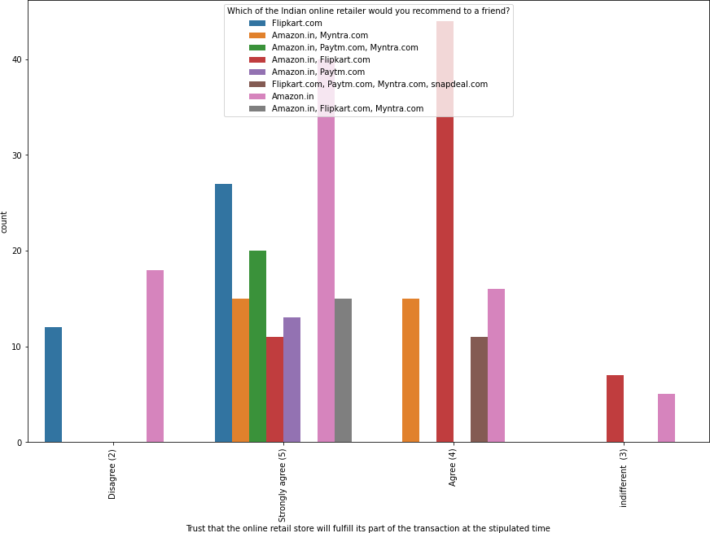

* Amazon is recommended as most trustworthy site followed by flipkart.

*#Empathy(readinesstoassistwithqueries)towardsthecustomers*

plt.figure(figsize=(10,10)) sn.countplot(x="Empathy(readinesstoassistwithqueries)towardsthecustomers",hue="W hichofthe Indianonlineretailerwouldyourecommendtoafriend?",data=df) plt.xticks(rotation=90) plt.show()

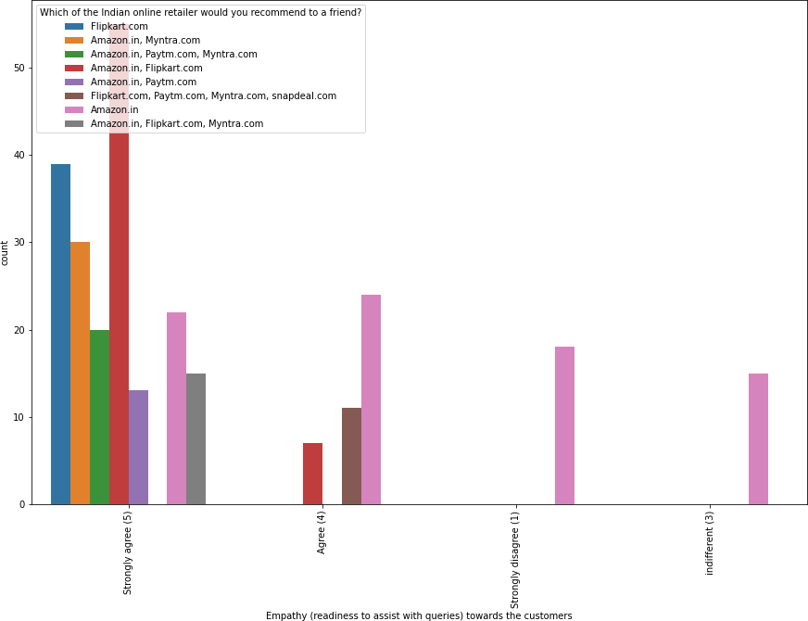

* Amazon and Flipkart recommended on the parameter of customer assistance.

*#Responsiveness,availabilityofseveralcommunicationchannels(email,onlinerep,twitt er,phoneetc.)*

plt.figure(figsize=(10,10)) sn.countplot(x="Responsivenessavailabilityofseveralcommunicationchannels(emailonl inereptwitterphoneetc.)",hue="WhichoftheIndianonlineretailerwouldyourecommendtoaf riend?",data=df)plt.xticks(rotation=90)

plt.show()

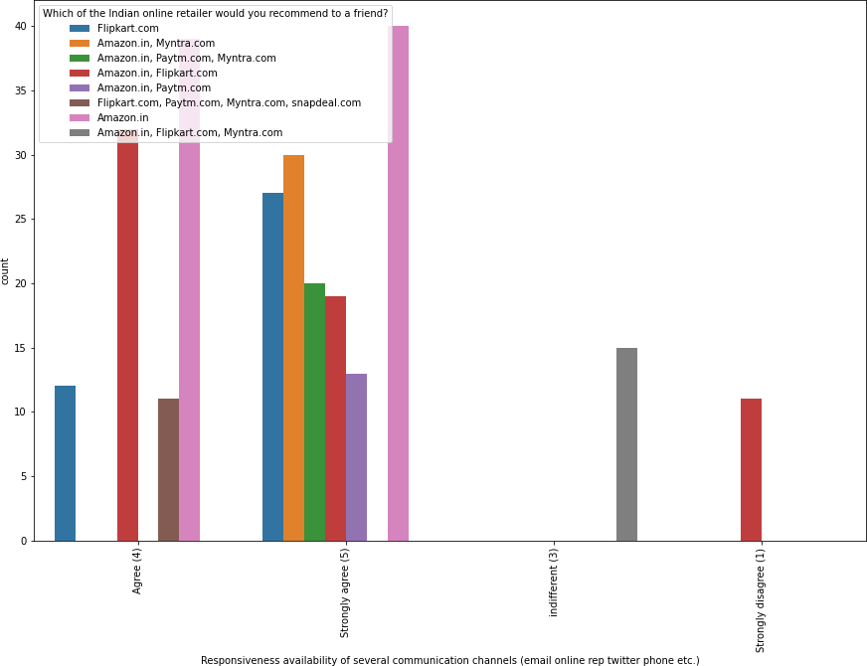

* Amazon and flipkart has been recommended on responsiveness, availability of several communication channel(email,onlinerp,twitter,phone etc.)

*#Onlineshoppinggivesmonetarybenefitanddiscounts*

plt.figure(figsize=(10,10)) sn.countplot(x="Onlineshoppinggivesmonetarybenefitanddiscounts",hue="Whichofthe Indianonlineretailerwouldyourecommendtoafriend?",data=df) plt.xticks(rotation=90)

plt.show()

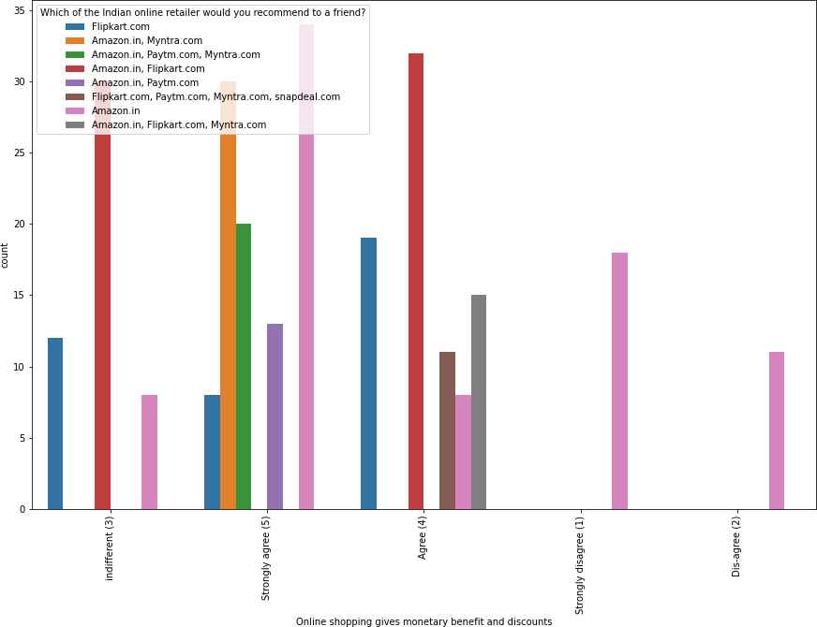

* Respondents suggest Amazon and Myntra provides most monetary benefit and discounts.

*#Enjoymentisderivedfromshoppingonline*

plt.figure(figsize=(10,10)) sn.countplot(x="Enjoymentisderivedfromshoppingonline",hue="WhichoftheIndianonline retailerwouldyourecommendtoafriend?",data=df)plt.xticks(rotation=90)

plt.show()

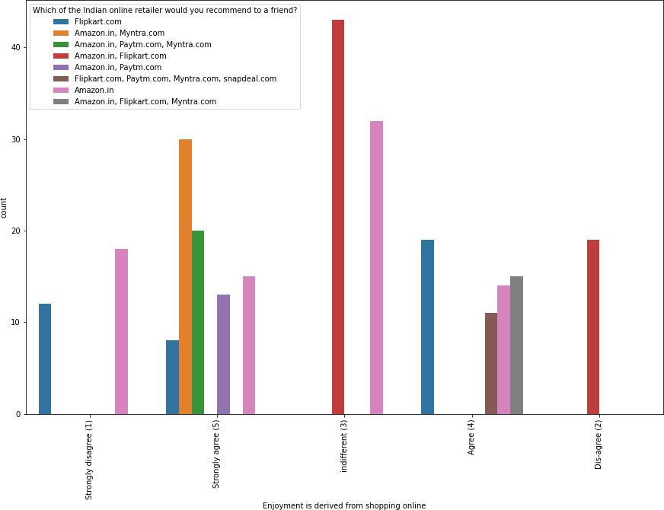

* People who agree with the statement enjoyment is derived from shopping online.

*#Shoppingonlineisconvenientandflexible*

plt.figure(figsize=(10,10)) sn.countplot(x="Shoppingonlineisconvenientandflexible",hue="WhichoftheIndianonlin eretailerwouldyourecommendtoafriend?",data=df)plt.xticks(rotation=90)

plt.show()

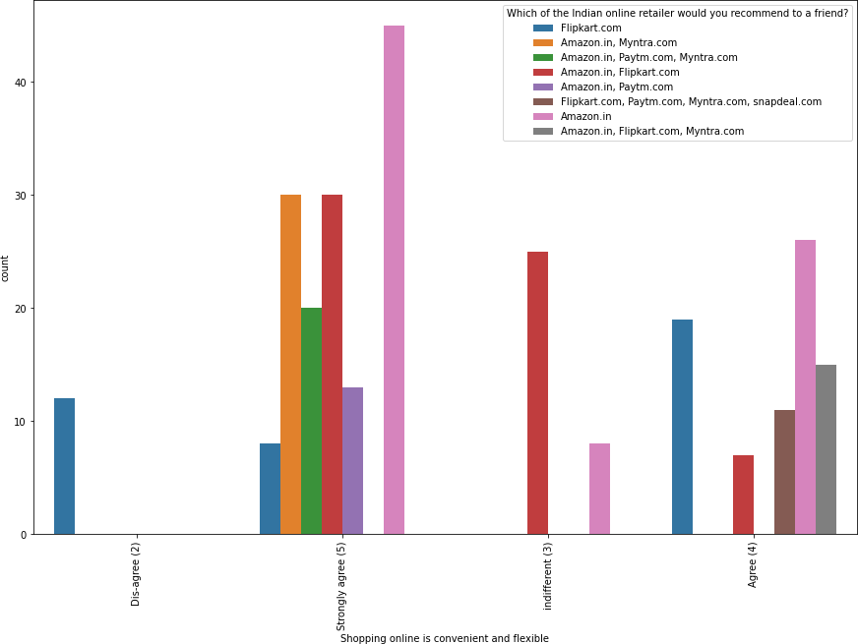

* respondents disaggreing with the stament Shopping online is convenient and flexible only recommend flipkart while people who strongly agree with this statment recommend multiple platforms

*#Returnandreplacementpolicyofthee-tailerisimportantforpurchase*␣*decision* plt.figure(figsize=(10,10)) sn.countplot(x="Returnandreplacementpolicyofthetailerisimportantforpurchasedecisio n",hue="WhichoftheIndianonlineretailerwouldyourecommendtoafriend?",data=df)plt.xt icks(rotation=90)

plt.show()

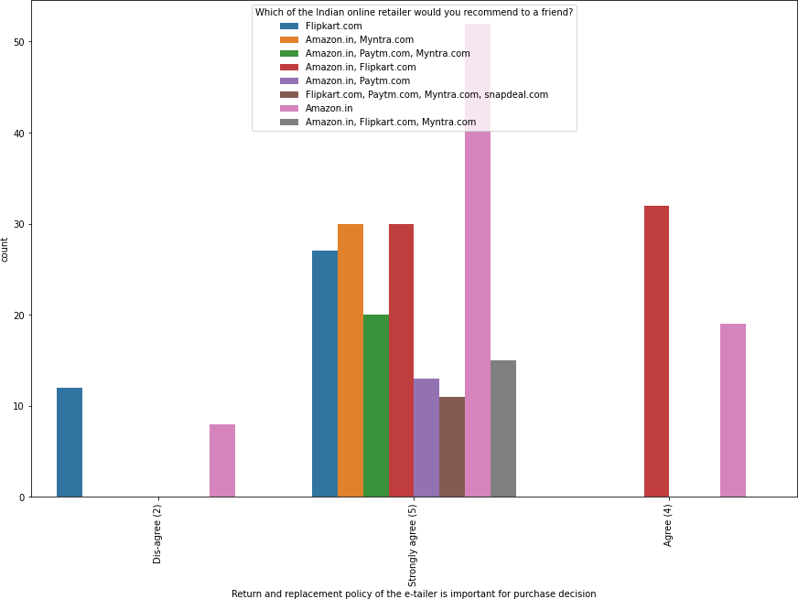

* Amazon is recommend it has best return and replacement policy of the e-tailer is important for purchase decision.

*#DisplayingqualityInformationonthewebsiteimprovessatisfactionofcustomers*

plt.figure(figsize=(10,10)) sn.countplot(x="DisplayingqualityInformationonthe websiteimproves␣

*‹→*satisfactionofcustomers",hue="Whichofthe Indianonlineretailerwould␣

*‹→*yourecommendtoafriend?",data=df)plt.xticks(rotation=90)

plt.show()

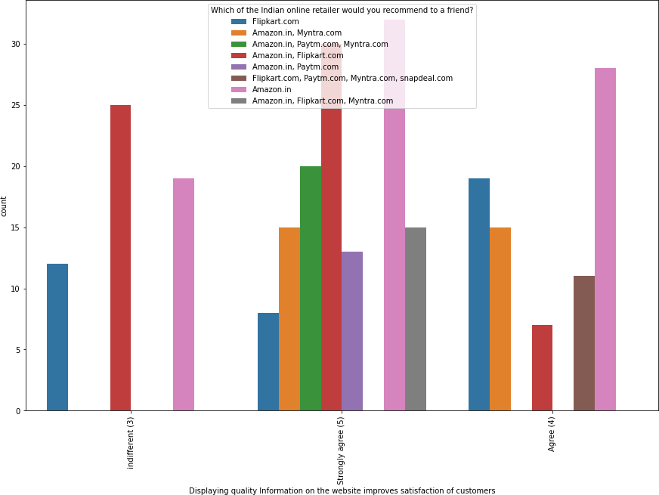

* On the basis of Displaying quality Information on the website improves satisfaction of customers respondents recommends Amazon and Flipkart mostly

*#Userderive satisfaction while shopping on a good quality website orapplication*

plt.figure(figsize=(10,10)) sn.countplot(x="Userderivesatisfactionwhileshoppingonagoodqualitywebsiteorapplica tion",hue="WhichoftheIndianonlineretailerwouldyourecommendtoafriend?",data=df)plt

.xticks(rotation=90) plt.show()

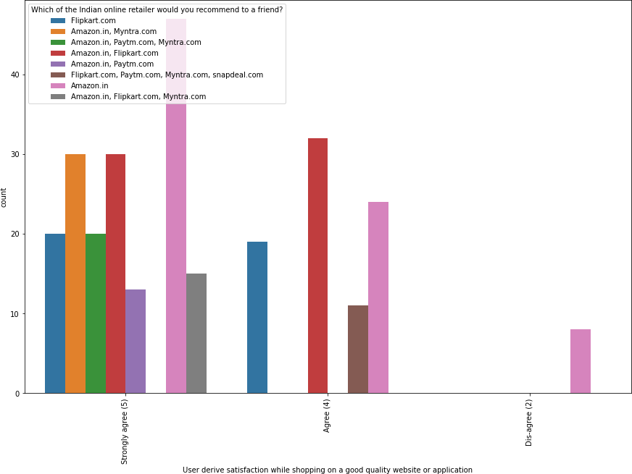

* According to respondents suggestion amazon provide most satisfaction while shopping on good quality website or application.

*#Usersatisfactioncannotexistwithouttrust*

plt.figure(figsize=(10,10)) sn.countplot(x="Usersatisfactioncannotexistwithouttrust",hue="Whichofthe Indianonlineretailerwouldyourecommendtoafriend?",data=df)plt.xticks(rotation=90) plt.show()

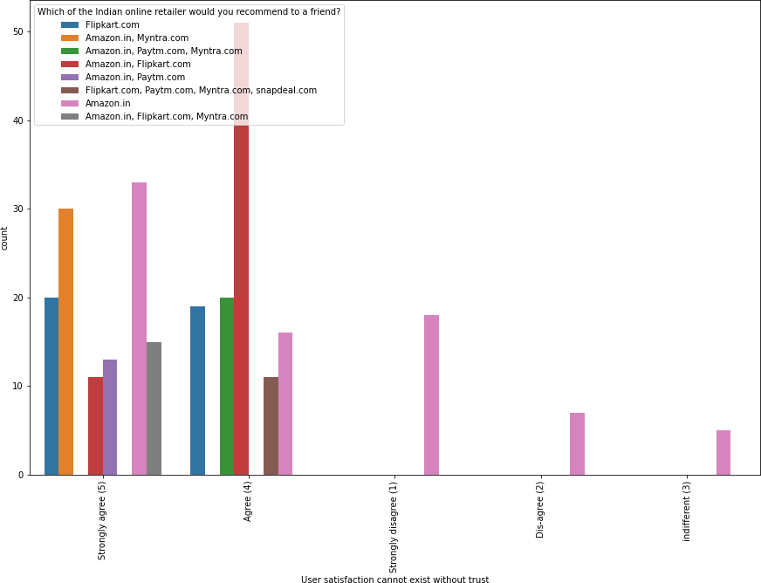

* Respondents who believe user satisfaction cannot exist without trust suggests Amazon and Flipkart.

*#Offeringawidevarietyoflistedproductinseveralcategory*

plt.figure(figsize=(10,10)) sn.countplot(x="Offeringawidevarietyoflistedproductinseveralcategory",hue="Which oftheIndianonlineretailerwouldyourecommendtoafriend?",data=df) plt.xticks(rotation=90)

plt.show()

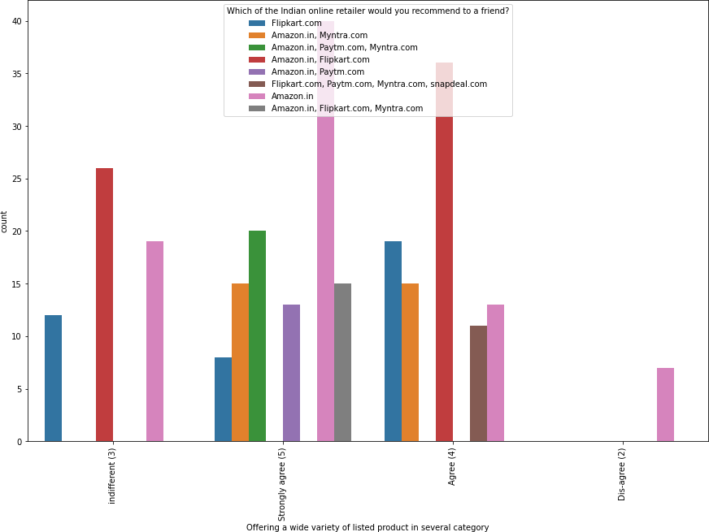

* On the basis of offering a wide variety of listed product in several category amazon is mostly recommended.

*#Shoppingonthewebsitegivesyouthesenseofadventure*

plt.figure(figsize=(10,10))

sn.countplot(x="Shoppingonthe websitegivesyouthesenseofadventure",hue="Whichofthe Indianonlineretailerwouldyourecommendtoafriend?",data=df) plt.xticks(rotation=90)

plt.show()

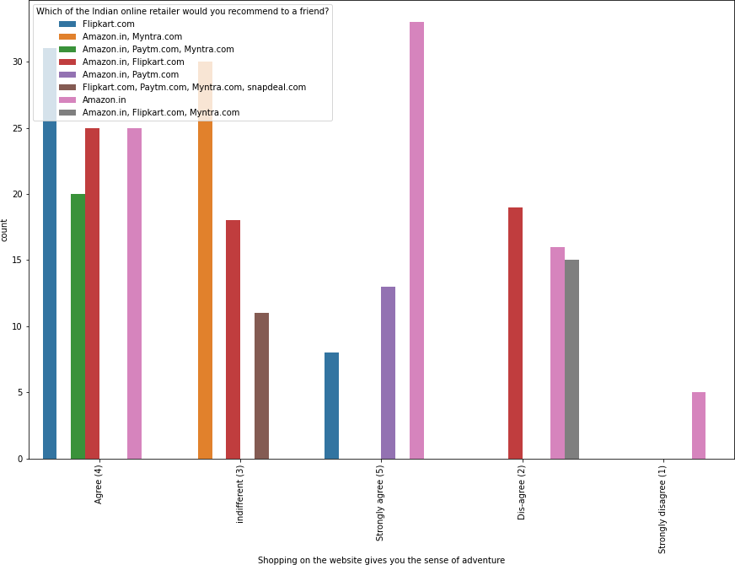

* According to respondents amazon suggesteded as shopping on the website gives you the sense of adventure.

*#Youfeel gratification shopping on your favorite e-tailer*

plt.figure(figsize=(10,10)) sn.countplot(x="Youfeelgratificationshoppingonyourfavoritetailer",hue="Whichofthe Indianonlineretailerwouldyourecommendtoafriend?",data=df) plt.xticks(rotation=90)

plt.show()

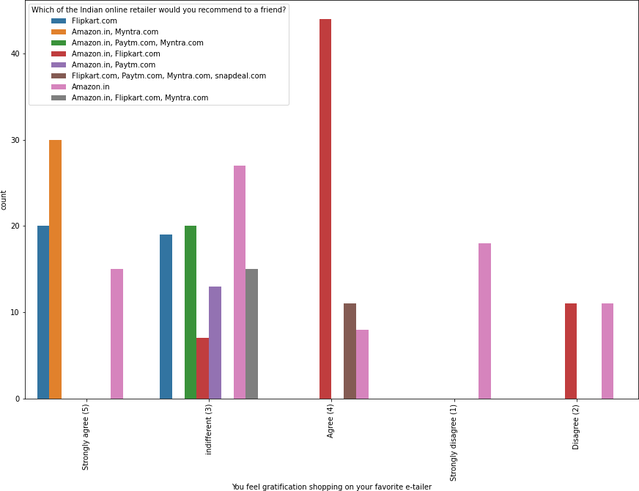

* Respondents who feels gratifaction shopping on your favorite e-tailer mostly suggest Myntra/Amazon/Flipkart.

*#Getting value for money spent*

plt.figure(figsize=(10,10)) sn.countplot(x="Gettingvalueformoneyspent",hue="WhichoftheIndianonlineretailerwo uldyourecommendtoafriend?",data=df)plt.xticks(rotation=90)

plt.show()

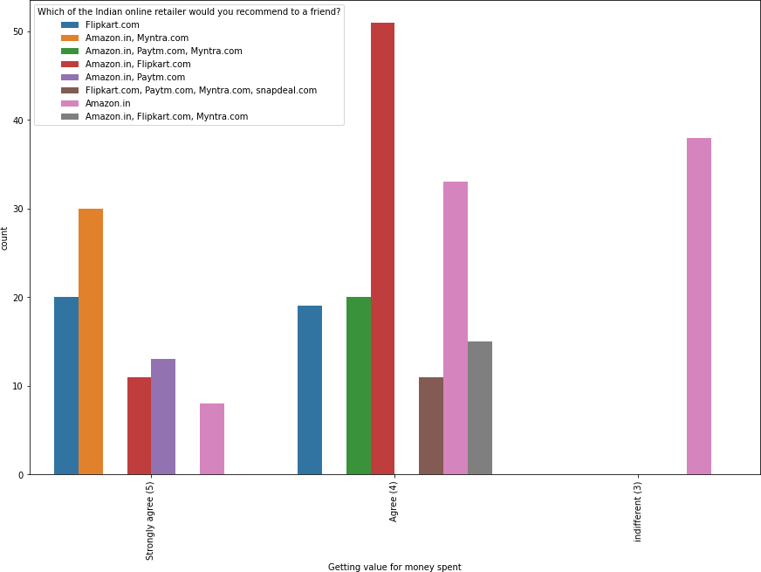

* Respondents suggest flipkart/myntra /amazon provides best value for money spent.

*#Whatis the operating system (OS) of your device?/'Which of the Indian online*␣

*‹→retailer would you recommend to a friend?*

df_plot=df.groupby(['Whatisthe operating system(OS)ofyourdevice?',␣

*‹→*'Whichofthe Indianonlineretailerwouldyourecommendtoafriend?']).

*‹→*size().reset_index().pivot(columns='Whatisthe operating system(OS)of␣

*‹→*yourdevice?',index='Whichofthe Indianonlineretailerwouldyou␣

*‹→*recommendtoafriend?',values=0)

df_plot.plot(kind='barh',stacked=**True**,figsize=(10,10),colormap="Set1",)plt.show(

)

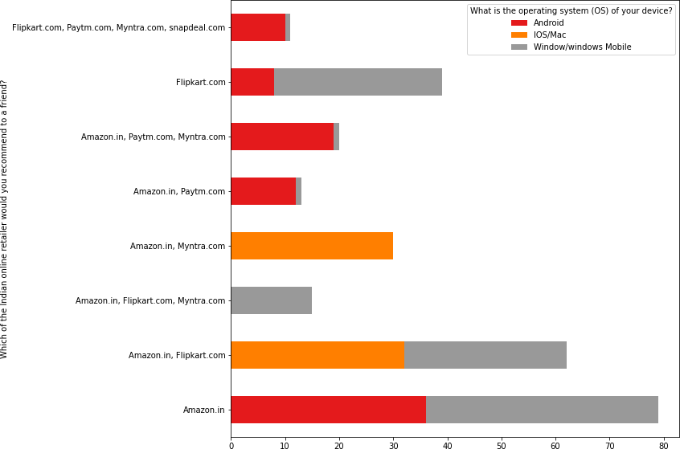

* Respondents who use window mobile are less likely to use myntra.com
* Respondents who uses IOS/Mac more likely to use Myntra.com

*#Whichcitydoyoushoponlinefrom?/WhichoftheIndianonlineretailerwould*␣

*‹→yourecommendtoafriend?*

df_plot=df.groupby(['Whichcitydoyoushoponlinefrom?','Whichofthe␣

*‹→*Indianonlineretailerwouldyourecommendtoafriend?']).size().

*‹→*reset_index().pivot(columns='Whichofthe Indianonlineretailerwouldyou␣

*‹→*recommendtoafriend?',index='Whichcitydoyoushoponlinefrom?',␣

*‹→*values=0)

df_plot.plot(kind='barh',stacked=**True**,figsize=(10,10),colormap="Set1",)plt

.legend(loc="lowerright",bbox_to_anchor=(1.6,.75),ncol=1) plt.show()

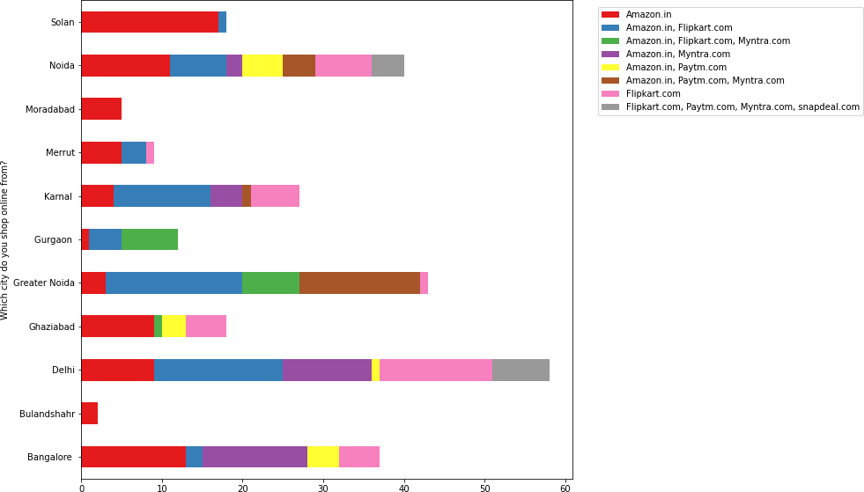

* + Cities with less shoppers prefer Amazon most for example Solan, Noida, Moradabad, Bulandshahr, Merrut
  + Cities with more number of shoppers recommends several platforms

**Multivariate Analysis**

*#checckingcorrelation* cor=df.corr() matrix=np.triu(df.corr())plt

.figure(figsize=(60,60)) sn.heatmap(cor,annot=**True**,mask=matrix,cbar=**False**)plt.show()

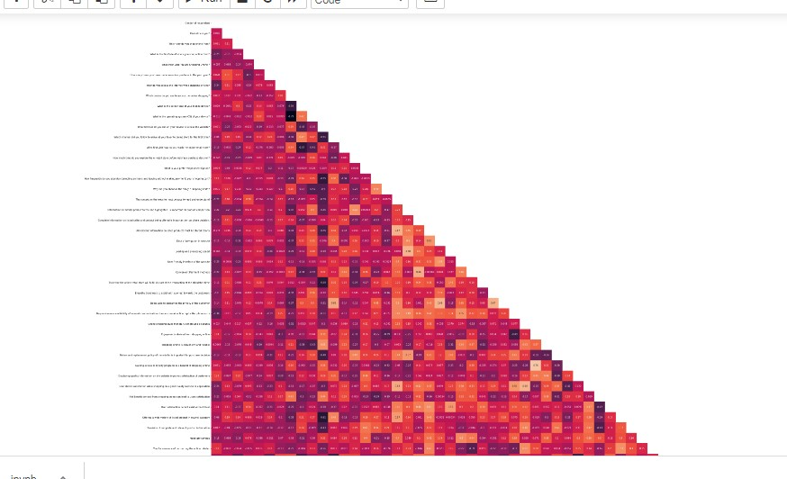

* + As there is so much variable so with heat map we can’t determine the

coorelation easily.

* + However the one thing we can say .There may be cases of multicolinearity.

*#sincetherearetomanycolumns,sortingcorrelationwithattritionin*␣

*‹→desendingorder*

df.corr()["WhichoftheIndianonlineretailerwouldyourecommendtoafriend?

*‹→*"].sort_values(ascending=**False**)

* WhichoftheIndianonlineretailerwouldyourecommendtoafriend? 1.000000
* Completerelevantdescriptioninformationofproducts

0.680926

* Reliabilityofthewebsiteorapplication 0.542711
* Easytousewebsiteorapplication 0.541713
* Presenceofonlineassistancethroughmulti-channel 0.503836
* PerceivedTrustworthiness 0.483457
* Whydidyouabandonthe“Bag”“ShoppingCart”?

0.448997

* Longerdeliveryperiod 0.428419
* Changeinwebsite/Applicationdesign 0.423877
* Availabilityofseveralpaymentoptions 0.416729
* Quicknesstocompletepurchase 0.398754
* Fastloadingwebsitespeedofwebsiteandapplication 0.335192
* Visualappealingwebpagelayout 0.316054
* Returnandreplacementpolicyofthee-tailerisimportantforpurchasedecision 0.311562
* WhatisyourpreferredpaymentOption? 0.308523
* Loadingandprocessingspeed 0.298070
* Howmuchtimedoyouexplorethee-retailstorebeforemakingapurchasedecision? 0.290108
* Afterfirstvisithowdoyoureachtheonlineretailstore?

0.279474

* Longerpageloadingtime(promotionsalesperiod) 0.278281
* Longertimetogetloggedin(promotionsalesperiod) 0.261774
* Websiteisasefficientasbefore 0.252154
* Provisionofcompleteandrelevantproductinformation 0.252121
* Latedeclarationofprice(promotionsalesperiod 0.231029
* Wildvarietyofproductonoffer 0.208213
* Youfeelgratificationshoppingonyourfavoritee-tailer 0.179228
* Fromthefollowingtickany(orall)oftheonlineretailersyouhaveshoppedfrom; 0.170697
* SinceHowLongYouareShoppingOnline? 0.136106
* Informationonsimilarproducttotheonehighlightedisimportantforproductcomparison 0.127227
* Frequentdisruptionwhenmovingfromonepagetoanother 0.122953
* Howfrequentlydoyouabandon(selectinganitemsandleavingwithoutmakingpayment)y ourshoppingcart?

0.119196

* Whichdevicedoyouusetoaccesstheonlineshopping? 0.099425
* Trustthattheonlineretailstorewillfulfillitspartofthetransactionatthestipulatedtie 0.095426
* Shoppingonyourpreferrede-tailerenhancesyoursocialstatus 0.074666
* Whatisthescreensizeofyourmobiledevice? 0.074453
* Shoppingonthewebsitehelpsyoufulfillcertainroles 0.069104
* Responsivenessavailabilityofseveralcommunicationchannels(emailonlinereptwipho neetc.)

0.035519

* Limitedmodeofpaymentonmostproducts(promotionsalesperiod) 0.028901
* Shoppingonthewebsitegivesyouthesenseofadventure 0.008540
* Genderofrespondent

-0.003372

* Howdoyouaccesstheinternetwhileshoppingon-line?

-0.012073

* Securityofcustomerfinancialinformation-0.01485
* Userderivesatisfactionwhileshoppingonagoodqualitywebsiteorapplication

-0.024465

* UserfriendlyInterfaceofthewebsite

-0.032348

* ConvenientPaymentmethods

-0.064096

* Whichchanneldidyoufollowtoarriveatyourfavoriteonlinestoreforthefirst time? - 0.071146
* Privacyofcustomers’information

-0.071876

* Monetarysavings

-0.079458

* Speedyorderdelivery

-0.089890

* WhatisthePinCodeofwhereyoushoponlinefrom?

-0.097320

* NetBenefitderivedfromshoppingonlinecanleadtouserssatisfaction

-0.126779

* Howoldareyou?

-0.135263

* Longertimeindisplayinggraphicsandphotos(promotionsalesperiod)

-0.140519

* Whichcitydoyoushoponlinefrom?

-0.142123

* Howmanytimesyouhavemadeanonlinepurchaseinthepast year?

-0.152028

* Offeringawidevarietyoflistedproductinseveralcategory

-0.154861

* Whatistheoperatingsystem(OS)ofyourdevice?

-0.159579

* Onlineshoppinggivesmonetarybenefitanddiscounts

-0.165739

* Completeinformationonlistedsellerandproductbeingofferedisimportantforpurchasedeci sion.

-0.172001

* Whatbrowserdoyourunonyourdevicetoaccessthewebsite?

-0.184207

* Easeofnavigationinwebsite

-0.193896

* DisplayingqualityInformationonthewebsiteimprovessatisfactionofcustomers

-0.197634

* TheConvenienceofpatronizingtheonlineretailer

-0.205473

* Gettingvalueformoneyspent

-0.230271

* Empathy(readinesstoassistwithqueries)towardsthecustomers

-0.232305

* Usersatisfactioncannotexistwithouttrust

-0.241386

* + Shoppingonlineisconvenientandflexible

-0.272532

* + Thecontentonthewebsitemustbeeasytoreadandunderstand

-0.349016

* + Beingabletoguaranteetheprivacyofthecustomer

-0.358734

* + Allrelevantinformationonlistedproductsmustbestatedclearly

-0.362879

* + Gainingaccesstoloyaltyprogramsisabenefitofshoppingonline

-0.400583

* + Enjoymentisderivedfromshoppingonline

-0.436613

Name:WhichoftheIndianonlineretailerwouldyourecommendtoafriend?,dtype:float 64

[211]:

*#Complete relevant description information of products*

*‹→ 0.680926*

*#Reliability of the website or application*

*‹→*

*#Easy to use website or application*

*‹→*

*0.542711*

*0.541713*

*#Presenceofonlineassistancethroughmulti-channel*

*‹→*

*#PerceivedTrustworthiness*

*‹→*

*0.503836*

*0.483457*

␣

␣

␣

␣

␣

### Thetoppositivelycorrelatedvariablewith“WhichoftheIndianonlin eretailerwouldyourecommendtoafriend?”are:-

[212]:

*#The content on the website must be easy to read and understand*

*‹→ -0.349016*

*#Beingabletoguaranteetheprivacyofthecustomer*

*‹→ -0.358734*

*#Allrelevantinformationonlistedproductsmustbestatedclearly*

*‹→ -0.362879*

*#Gaining access to loyalty programs isa benefit of shopping online*

*‹→ -0.400583*

*#Enjoymentisderivedfromshoppingonline*

␣

␣

␣

␣

␣

*‹→ -0.436613*

1. **Thetopnegativelycorrelatedvariablewith“WhichoftheIn- dianonlineretailerwouldyourecommendtoafriend?”are:-**

## CONCLUSION

As in the final conclusion in which user were asked which online retailer they would recommend to a friend. Most of the respondents says Amazon. in because it is providing all the features that users want. Website is efficient and it is fast loading , It give complete , relevant description and information of products . It is reliable and quick to complete the purchase. Amazon give speedy delivery to its customers and there is several payment option avaliable on the website. It provide online assistance through multi channels. Providing good deals on products. Amazon have a user friendly interface and has visual appealing webpage layout. Amazon also offers wide variety of products and its application is easy to use . lastly the main thing why user recommend it is because of its Trustworthiness and also its robust Security in protecting customer financial information and their Privacy information .

They are some cons like the amazon website topping the list In Frequent disruption when moving from one page to another this con company should see and improve it to give overall best experience to the users.

This paper investigated the factors that influence the online customers repeat purchase intention. During the process various data processing methods has been used to clean the data. The project contains extensive EDA considering every aspect. The major finding is Complete relevant description of products and reliability of the website increases chances of customer retention. However, if the content on the website in not easy to read and understand or can’t guarantee the privacy of the customer will lead to chances of customer retention. This project has increased my understanding of the concept. During the research I came across various challenges and while solving them I learned a lot of new things. How to plot different charts. For example, I learned how to plot subplot. How to handle legends manually. How to group data and visualize that.

The limitation of the solution provided is that the data carried a lot of unrealistic values. Apart from that my laptop took to much time while running certain command where I lost a lot of precious time.